UNITED STATES
SECURITIES AND EXCHANGE COMMISSION
Washington, D.C. 20549

Schedule 14A

(Rule 14a-101)
INFORMATION REQUIRED IN PROXY STATEMENT
SCHEDULE 14A INFORMATION

Proxy Statement Pursuant to Section 14(a)
of the Securities Exchange Act of 1934

Filed by the Registrant | ☒
Filed by a party other than the Registrant | ☐

Check the appropriate box:

☐ | Preliminary Proxy Statement
☐ | Confidential, for Use of the Commission Only (as permitted by Rule 14a-6(e)(2))
☐ | Definitive Proxy Statement
☒ | Definitive Additional Materials
☐ | Soliciting Material Pursuant to §240.14a-12

SkinHealth Systems Inc.
(Name of Registrant as Specified in its Charter)

(Name of Person(s) Filing Proxy Statement, if Other Than the Registrant)

Payment of Filing Fee (Check the appropriate box):

☒ | No fee required
☐ | Fee paid previously with preliminary materials
☐ | Fee computed on table in exhibit required by Item 25(b) per Exchange Act Rules 14a-6(i)(1) and 0-11

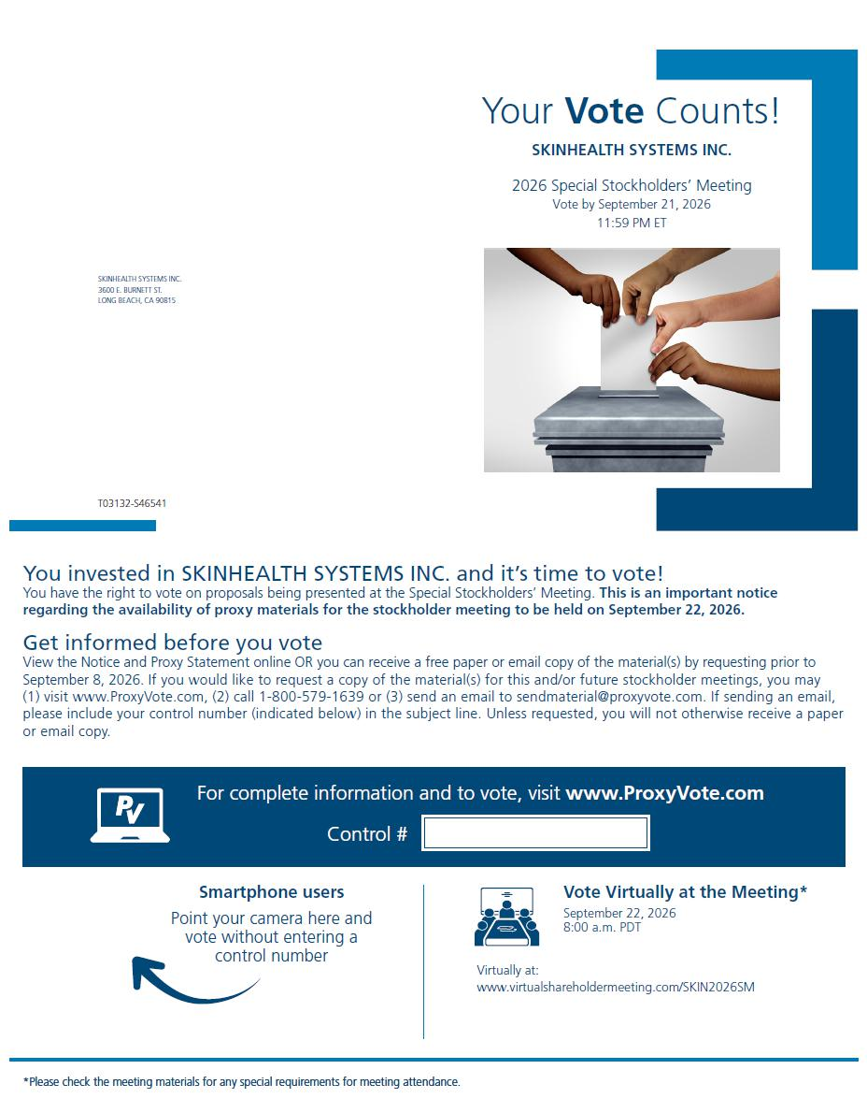

Your Vote Counts! Smartphone users Point your camera here and vote without entering a control number For complete information and to vote, visit www.ProxyVote.com Control # T03132 - S46541 *Please check the meeting materials for any special requirements for meeting attendance. You invested in SKINHEALTH SYSTEMS INC. and it’s time to vote! You have the right to vote on proposals being presented at the Special Stockholders’ Meeting. This is an important notice regarding the availability of proxy materials for the stockholder meeting to be held on September 22, 2026. Get informed before you vote View the Notice and Proxy Statement online OR you can receive a free paper or email copy of the material(s) by requesting prior to September 8, 2026. If you would like to request a copy of the material(s) for this and/or future stockholder meetings, you may (1) visit www.ProxyVote.com, (2) call 1 - 800 - 579 - 1639 or (3) send an email to sendmaterial@proxyvote.com. If sending an email, please include your control number (indicated below) in the subject line. Unless requested, you will not otherwise receive a paper or email copy. SKINHEALTH SYSTEMS INC. 2026 Special Stockholders’ Meeting Vote by September 21, 2026 11:59 PM ET Virtually at: www.virtualshareholdermeeting.com/SKIN2026SM SKINHEALTH SYSTEMS INC. 3600 E. BURNETT ST. LONG BEACH, CA 90815 Vote Virtually at the Meeting* September 22, 2026 8:00 a.m. PDT

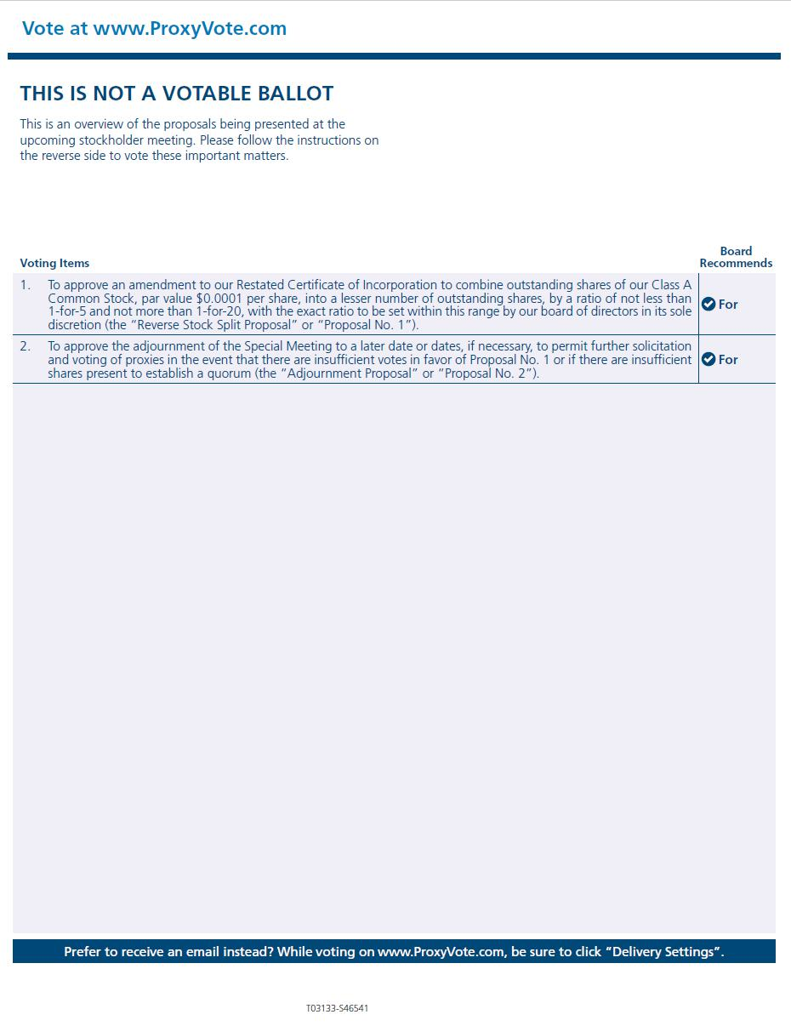

Vote at www.ProxyVote.com THIS IS NOT A VOTABLE BALLOT This is an overview of the proposals being presented at the upcoming stockholder meeting. Please follow the instructions on the reverse side to vote these important matters. Prefer to receive an email instead? While voting on www.ProxyVote.com, be sure to click “Delivery Settings”. For 1 . To approve an amendment to our Restated Certificate of Incorporation to combine outstanding shares of our Class A Common Stock, par value $ 0 . 0001 per share, into a lesser number of outstanding shares, by a ratio of not less than 1 - for - 5 and not more than 1 - for - 20 , with the exact ratio to be set within this range by our board of directors in its sole discretion (the “Reverse Stock Split Proposal” or “Proposal No . 1 ”) . For 2 . To approve the adjournment of the Special Meeting to a later date or dates, if necessary, to permit further solicitation and voting of proxies in the event that there are insufficient votes in favor of Proposal No . 1 or if there are insufficient shares present to establish a quorum (the “Adjournment Proposal” or “Proposal No . 2 ”) . Voting Items Board Recommends T03133 - S46541

