UNITED STATES

SECURITIES AND EXCHANGE COMMISSION

Washington, D.C. 20549

FORM 10-Q

- QUARTERLY REPORT PURSUANT TO SECTION 13 OR 15(d) OF THE SECURITIES EXCHANGE ACT OF 1934

For the quarterly period ended March 31, 2024

- TRANSITION REPORT PURSUANT TO SECTION 13 OR 15(d) OF THE SECURITIES EXCHANGE ACT OF 1934 For the transition period from __________ to __________.

 | Commission File Number: 001-39565
The Beauty Health Company
 | (Exact name of registrant as specified in its charter)
Delaware |  |  | 85-1908962
(State or other jurisdiction of |  |  | (I.R.S. Employer Identification No.)
incorporation or organization)
2165 Spring Street |  |  | (800) 603-4996
Long Beach, CA 90806 |  |  | (800) 603-4996
(Address of principal executive offices, including zip code) |  |  | Registrant's telephone number, including area code

N/A

(Former name, former address and former fiscal year, if changed since last report)

Securities registered pursuant to Section 12(b) of the Act:

Title of each class |  | Trading Symbol(s) |  | Name of each exchange on which registered
Class A Common Stock, par value $0.0001 per share |  | SKIN |  | The Nasdaq Capital Market

Indicate by check mark whether the registrant (1) has filed all reports required to be filed by Section 13 or 15(d) of the Securities Exchange Act of 1934 during the preceding 12 months (or for such shorter period that the registrant was required to file such reports), and (2) has been subject to such filing requirements for the past 90 days. Yes ☒ No ☐

Indicate by check mark whether the registrant has submitted electronically every Interactive Data File required to be submitted pursuant to Rule 405 of Regulation S-T (§232.405 of this chapter) during the preceding 12 months (or for such shorter period that the registrant was required to submit such files). Yes ☒ No ☐

Indicate by check mark whether the registrant is a large accelerated filer, an accelerated filer, a non-accelerated filer, a smaller reporting company, or an emerging growth company. See definitions of “large accelerated filer”, “accelerated filer”, “smaller reporting company”, and “emerging growth company” in Rule 12b-2 of the Exchange Act.
Large accelerated filer | ☒ | Accelerated filer | ☐
Non-accelerated filer | ☐ | Smaller reporting company | ☐
 |  | Emerging growth company | ☐

If an emerging growth company, indicate by check mark if the registrant has elected not to use the extended transition period for complying with any new or revised financial accounting standards provided pursuant to Section 13(a) of the Exchange Act. ☐

Indicate by check mark whether the registrant is a shell company (as defined in Rule 12b-2 of the Exchange Act). Yes ☐ No ☒

As of May 6, 2024, there were 123,632,222 shares of Class A Common Stock, par value $0.0001 per share issued and outstanding.

THE BEAUTY HEALTH COMPANY

FORM 10-Q FOR THE QUARTER ENDED MARCH 31, 2024

TABLE OF CONTENTS

 |  |  |  |  |  |  |  |  |  |  |  |  |  |  | Page
PART I—FINANCIAL INFORMATION
Item 1. |  | Financial Statements |  |  |  |  |  |  |  |  |  |  |  |  | 3
 |  | Condensed Consolidated Balance Sheets (Unaudited) |  |  |  |  |  |  |  |  |  |  |  |  | 3
 |  | Condensed Consolidated Statements of Comprehensive Income (Loss) (Unaudited) |  |  |  |  |  |  |  |  |  |  |  |  | 4
 |  | Condensed Consolidated Statements of Stockholders’ Equity (Deficit) (Unaudited) |  |  |  |  |  |  |  |  |  |  |  |  | 5
 |  | Condensed Consolidated Statements of Cash Flows (Unaudited) |  |  |  |  |  |  |  |  |  |  |  |  | 6
 |  | Notes to Condensed Consolidated Financial Statements (Unaudited) |  |  |  |  |  |  |  |  |  |  |  |  | 7
Item 2. |  | Management’s Discussion and Analysis of Financial Condition and Results of Operations |  |  |  |  |  |  |  |  |  |  |  |  | 21
Item 3. |  | Quantitative and Qualitative Disclosures About Market Risk |  |  |  |  |  |  |  |  |  |  |  |  | 28
Item 4. |  | Controls and Procedures |  |  |  |  |  |  |  |  |  |  |  |  | 28
PART II—OTHER INFORMATION
Item 1. |  | Legal Proceedings |  |  |  |  |  |  |  |  |  |  |  |  | 30
Item 1A. |  | Risk Factors |  |  |  |  |  |  |  |  |  |  |  |  | 30
Item 2. |  | Unregistered Sales of Equity Securities and Use of Proceeds |  |  |  |  |  |  |  |  |  |  |  |  | 30
Item 3. |  | Defaults Upon Senior Securities |  |  |  |  |  |  |  |  |  |  |  |  | 30
Item 4. |  | Mine Safety Disclosures |  |  |  |  |  |  |  |  |  |  |  |  | 30
Item 5. |  | Other Information |  |  |  |  |  |  |  |  |  |  |  |  | 30
Item 6. |  | Exhibits |  |  |  |  |  |  |  |  |  |  |  |  | 31
SIGNATURES

2

PART I— FINANCIAL INFORMATION

Item 1. Financial Statements.

THE BEAUTY HEALTH COMPANY

CONDENSED CONSOLIDATED BALANCE SHEETS

(in thousands, except for share amounts)

(Unaudited)

 |  | March 31, 2024 |  |  | December 31, 2023
ASSETS
Current assets:
Cash, cash equivalents, and restricted cash | $ | 444,634 |  | $ | 523,025
Accounts receivable, net of allowances for estimated credit losses of $7,228 and $6,604 at March 31, 2024 and
December 31, 2023, respectively |  | 47,666 |  |  | 54,697
Inventories |  | 95,721 |  |  | 91,321
Income tax receivable |  | 1,204 |  |  | 332
Prepaid expenses and other current assets |  | 25,599 |  |  | 28,877
Total current assets |  | 614,824 |  |  | 698,252
Property and equipment, net |  | 12,048 |  |  | 14,226
Right-of-use assets, net |  | 16,383 |  |  | 12,120
Intangible assets, net |  | 58,405 |  |  | 62,123
Goodwill |  | 125,365 |  |  | 125,818
Deferred income tax assets, net |  | 1,932 |  |  | 531
Other assets |  | 15,784 |  |  | 16,043
TOTAL ASSETS | $ | 844,741 |  | $ | 929,113
LIABILITIES AND STOCKHOLDERS’ EQUITY
Current liabilities:
Accounts payable | $ | 37,312 |  | $ | 44,768
Accrued payroll-related expenses |  | 15,456 |  |  | 22,028
Syndeo Program reserves |  | 8,314 |  |  | 21,009
Lease liabilities, current |  | 4,648 |  |  | 4,598
Income tax payable |  | 3,443 |  |  | 2,759
Other accrued expenses |  | 24,395 |  |  | 19,846
Total current liabilities |  | 93,568 |  |  | 115,008
Lease liabilities, non-current |  | 13,688 |  |  | 9,319
Deferred income tax liabilities, net |  | 1,068 |  |  | 702
Warrant liabilities |  | 5,019 |  |  | 3,555
Convertible senior notes, net |  | 665,486 |  |  | 738,372
Other long-term liabilities |  | 2,617 |  |  | 2,767
Total liabilities |  | 781,446 |  |  | 869,723
Commitments (Note 10)
Stockholders’ equity:
Class A Common Stock, $0.0001 par value; 320,000,000 shares authorized; 123,453,419 and 122,899,002 shares issued
and outstanding at March 31, 2024 and December 31, 2023, respectively |  | 12 |  |  | 12
Additional paid-in capital |  | 546,912 |  |  | 541,281
Accumulated other comprehensive loss |  | (4,083) |  |  | (3,036)
Accumulated deficit |  | (479,546) |  |  | (478,867)
Total stockholders’ equity |  | 63,295 |  |  | 59,390
TOTAL LIABILITIES AND STOCKHOLDERS’ EQUITY
TOTAL LIABILITIES AND STOCKHOLDERS’ EQUITY | $ | 844,741 |  | $ | 929,113

The accompanying notes are an integral part of these unaudited financial statements.

3

THE BEAUTY HEALTH COMPANY

CONDENSED CONSOLIDATED STATEMENTS OF COMPREHENSIVE INCOME (LOSS)

(in thousands, except for share and per share amounts)

(Unaudited)

 |  | Three Months Ended March 31,
 |  | 2024 |  |  | 2023
Net sales | $ | 81,403 |  | $ | 86,278
Cost of sales |  | 33,042 |  |  | 32,174
Gross profit |  | 48,361 |  |  | 54,104
Operating expenses:
Selling and marketing |  | 33,684 |  |  | 38,699
Research and development |  | 2,807 |  |  | 2,336
General and administrative |  | 28,861 |  |  | 30,379
Total operating expenses |  | 65,352 |  |  | 71,414
Loss from operations |  | (16,991) |  |  | (17,310)
Interest expense |  | 3,029 |  |  | 3,417
Interest income |  | (5,356) |  |  | (4,315)
Other income, net |  | (16,087) |  |  | (418)
Change in fair value of warrant liabilities |  | 1,464 |  |  | 9,076
Foreign currency transaction loss (gain), net |  | 1,297 |  |  | (1,149)
Loss before provision for income taxes |  | (1,338) |  |  | (23,921)
Income tax benefit |  | (659) |  |  | (3,662)
Net loss | $ | (679) |  | $ | (20,259)
Comprehensive loss, net of tax:
Foreign currency translation adjustments |  | (1,047) |  |  | 888
Comprehensive loss | $ | (1,726) |  | $ | (19,371)
Net loss per share
Basic | $ | (0.01) |  | $ | (0.15)
Diluted | $ | (0.10) |  | $ | (0.15)
Weighted average common shares outstanding
Basic |  | 123,120,426 |  |  | 132,420,762
Diluted |  | 144,477,208 |  |  | 132,420,762

The accompanying notes are an integral part of these unaudited financial statements.

4

THE BEAUTY HEALTH COMPANY

CONDENSED CONSOLIDATED STATEMENTS OF STOCKHOLDERS’ EQUITY (DEFICIT)

(in thousands, except for share amounts)

(Unaudited)

 | Common Stock |  |  |  |  |  |  |  | Accumulated Other
 |  |  |  |  |  | Additional Paid-in |  |  |  | Comprehensive |  |  | Accumulated |  | Total Stockholders’ Equity
 |  |  |  |  |  |  |  |  |  | Income (Loss)
 | Shares |  |  | Amount |  |  | Capital |  |  |  |  |  | Deficit |  |  | (Deficit)
BALANCE, December 31, 2022 | 132,214,695 |  | $ | 14 |  | $ | 550,320 |  | $ | (4,530) |  | $ | (378,751) |  | $ | 167,053
Net loss | — |  |  | — |  |  | — |  |  | — |  |  | (20,259) |  |  | (20,259)
Issuance of Common Stock pursuant to equity compensation plan | 473,049 |  |  | — |  |  | — |  |  | — |  |  | — |  |  | —
Shares withheld for tax withholdings on vested stock awards | (170,415) |  |  | — |  |  | (2,195) |  |  | — |  |  | — |  |  | (2,195)
Issuance of Common Stock relating to employee stock purchase plan | — |  |  | — |  |  | 2,034 |  |  | — |  |  | — |  |  | 2,034
Share-based compensation | — |  |  | — |  |  | 3,577 |  |  | — |  |  | — |  |  | 3,577
Common Stock relating to asset acquisition | 109,625 |  |  | — |  |  | 1,310 |  |  | — |  |  | — |  |  | 1,310
Foreign currency translation adjustment | — |  |  | — |  |  | — |  |  | 888 |  |  | — |  |  | 888
BALANCE, March 31, 2023 | 132,626,954 |  | $ | 14 |  | $ | 555,046 |  | $ | (3,642) |  | $ | (399,010) |  | $ | 152,408
BALANCE, December 31, 2023 | 122,899,002 |  | $ | 12 |  | $ | 541,281 |  | $ | (3,036) |  | $ | (478,867) |  | $ | 59,390
Net loss | — |  |  | — |  |  | — |  |  | — |  |  | (679) |  |  | (679)
Issuance of Common Stock pursuant to equity compensation plan | 843,950 |  |  | — |  |  | — |  |  | — |  |  | — |  |  | —
Shares withheld for tax withholdings on vested stock awards | (289,533) |  |  | — |  |  | (1,005) |  |  | — |  |  | — |  |  | (1,005)
Share-based compensation | — |  |  | — |  |  | 6,636 |  |  | — |  |  | — |  |  | 6,636
Foreign currency translation adjustment | — |  |  | — |  |  | — |  |  | (1,047) |  |  | — |  |  | (1,047)
BALANCE, March 31, 2024 | 123,453,419 |  | $ | 12 |  | $ | 546,912 |  | $ | (4,083) |  | $ | (479,546) |  | $ | 63,295

The accompanying notes are an integral part of these unaudited financial statements.

5

THE BEAUTY HEALTH COMPANY

CONDENSED CONSOLIDATED STATEMENTS OF CASH FLOWS

(in thousands)

(Unaudited)

 | Three Months Ended March 31,
 | 2024 |  |  | 2023
Cash flows from operating activities:
Net loss | $ | (679) |  | $ | (20,259)
Adjustments to reconcile net loss to net cash from operating activities
Share-based compensation |  | 6,636 |  |  | 3,577
Amortization of intangible assets |  | 4,985 |  |  | 3,874
Depreciation of property and equipment |  | 2,773 |  |  | 1,834
Amortization of other assets |  | 890 |  |  | 548
Amortization of debt issuance costs |  | 951 |  |  | 1,058
Inventory write-down |  | 5,479 |  |  | 3,337
Provision for estimated credit losses |  | 656 |  |  | 1,093
Change in fair value of warrant liabilities |  | 1,464 |  |  | 9,076
Gain on repurchase of convertible senior notes, net |  | (16,087) |  |  | —
Deferred income taxes |  | (1,030) |  |  | (279)
Other, net |  | 3,108 |  |  | (515)
Changes in operating assets and liabilities:
Accounts receivable |  | 5,879 |  |  | 4,793
Inventories |  | (11,081) |  |  | (13,905)
Prepaid expenses, other current assets, and income tax receivable |  | 1,936 |  |  | (1,325)
Accounts payable, accrued expenses, and income tax payable |  | (20,786) |  |  | (3,829)
Other, net |  | (1,948) |  |  | (2,088)
Net cash used for operating activities |  | (16,854) |  |  | (13,010)
Cash flows from investing activities:
Cash paid for intangible assets |  | (1,458) |  |  | (2,450)
Cash paid for property and equipment |  | (344) |  |  | (2,319)
Cash paid for asset acquisitions |  | — |  |  | (16,915)
Net cash used for investing activities |  | (1,802) |  |  | (21,684)
Cash flows from financing activities:
Repurchase of convertible senior notes |  | (57,750) |  |  | —
Payment of tax withholdings on vested stock awards |  | (868) |  |  | (2,195)
Net cash used for financing activities |  | (58,618) |  |  | (2,195)
Net change in cash, cash equivalents, and restricted cash |  | (77,274) |  |  | (36,889)
Effect of foreign currency translation on cash |  | (1,117) |  |  | 974
Cash, cash equivalents, and restricted cash beginning of period |  | 523,025 |  |  | 568,197
Cash, cash equivalents, and restricted cash end of period | $ | 444,634 |  | $ | 532,282

The accompanying notes are an integral part of these unaudited financial statements

6

THE BEAUTY HEALTH COMPANY

NOTES TO CONDENSED CONSOLIDATED FINANCIAL STATEMENTS

(Unaudited)

Note 1 — Description of Business

The Beauty Health Company (the “Company”) is a global category-creating company focused on delivering skin health experiences that help consumers reinvent their relationship with their skin, bodies, and self-confidence. The Company and its subsidiaries design, develop, manufacture, market, and sell esthetic technologies and products. The Company’s brands are pioneers: Hydrafacial in hydradermabrasion; SkinStylus in microneedling; and Keravive in scalp health. Together, with its powerful global community of estheticians, partners, and consumers, the Company is personalizing skin health for all ages, genders, skin tones, and skin types.

Historical Information

The Company (f.k.a. Vesper Healthcare Acquisition Corp.) was incorporated in the State of Delaware on July 8, 2020. On May 4, 2021, we consummated the previously announced business combination pursuant to that certain Agreement and Plan of Merger, dated December 8, 2020, by and among Vesper Healthcare Acquisition Corp. (“Vesper Healthcare”), Hydrate Merger Sub I, Inc. (“Merger Sub I”), Hydrate Merger Sub II, LLC (“Merger Sub II”), LCP Edge Intermediate, Inc., the indirect parent of HydraFacial LLC, f.k.a. Edge Systems LLC (“Hydrafacial”), and LCP Edge Holdco, LLC (“LCP,” or “Former Parent,” and, in its capacity as the stockholders’ representative, the “Stockholders’ Representative”) (the “Merger Agreement”), which provided for: (a) the merger of Merger Sub I with and into Hydrafacial, with Hydrafacial continuing as the surviving corporation (the “First Merger”), and (b) immediately following the First Merger and as part of the same overall transaction as the First Merger, the merger of Hydrafacial with and into Merger Sub II, with Merger Sub II continuing as the surviving entity (the “Second Merger” and, together with the First Merger, the “Mergers” and, together with the other transactions contemplated by the Merger Agreement, the “Business Combination”). As a result of the First Merger, the Company owns 100% of the outstanding common stock of Hydrafacial and each share of common stock and preferred stock of Hydrafacial was cancelled and converted into the right to receive a portion of the consideration payable in connection with the Mergers. As a result of the Second Merger, the Company owns 100% of the outstanding interests in Merger Sub II. In connection with the closing of the Business Combination, the Company owns, directly or indirectly, 100% of the stock of Hydrafacial and its subsidiaries and the stockholders of Hydrafacial as of immediately prior to the effective time of the First Merger (the “Hydrafacial Stockholders”) hold a portion of the Company’s Class A common stock, par value $0.0001 per share (the “Class A Common Stock”).

Basis of Presentation

The accompanying unaudited interim financial statements have been prepared in accordance with the instructions to Form 10-Q and Article 10 of Regulation S-X. Accordingly, they do not include all information and footnotes required by accounting principles generally accepted in the United States of America (“GAAP”) for complete financial statements. These statements reflect all normal and recurring adjustments which, in the opinion of management, are necessary to present fairly the financial position, results of operations and cash flows of the Company for the interim periods presented.

These interim financial statements should be read in conjunction with the audited consolidated financial statements and notes thereto included in, or presented as exhibits to, the Company’s Annual Report on Form 10-K for the year ended December 31, 2023.

Subsequent to the issuance of the Company’s Quarterly Report on Form 10-Q for the three months ended March 31, 2023, during the quarter ended June 30, 2023, the Company identified prior period misstatements related to the elimination of intercompany balances and right of return assets. Although the Company concluded that these misstatements were not material, either individually or in the aggregate, the Company elected to revise its previously issued unaudited consolidated financial statements to correct for these misstatements.

The revision of the previously issued unaudited consolidated financial statements is presented in the accompanying unaudited consolidated financial statements and related disclosures. For further detail, refer to Note 16 – Revision for Immaterial Misstatements.

7

Note 2 — Revenue

The Company generates revenue through manufacturing and selling its patented hydradermabrasion delivery systems (“Delivery Systems”). In conjunction with the sale of Delivery Systems, the Company also sells single-use tips, solutions, and serums used to provide a Hydrafacial treatment that cleanses, extracts, and hydrates the skin (collectively “Consumables”). Original Consumables are sold solely and exclusively by the Company (and from authorized retailers) and are available for purchase separately from the purchase of Delivery Systems. For both Delivery Systems and Consumables, revenue is recognized upon transfer of control to the customer, which generally takes place at the point of shipment.

The Company manages its business on the basis of one operating segment and one reportable segment. As a result, the chief operating decision maker, who is the Chief Executive Officer, reviews financial information presented on a consolidated basis for purposes of making operating decisions, allocating resources and evaluating financial performance.

The Company’s revenue disaggregated by major product line consists of the following for the periods indicated:

 |  |  |  | Three Months Ended March 31,
(in thousands) |  |  |  | 2024 |  |  |  |  | 2023
Net Sales
Delivery Systems | $ |  |  | 35,783 |  |  |  | $ | 45,353
Consumables |  |  |  | 45,620 |  |  |  |  | 40,925
Total net sales |  |  | $ | 81,403 |  |  |  | $ | 86,278
Net sales by geographic region were as follows for the periods indicated:
 |  |  |  | Three Months Ended March 31,
(in thousands) |  |  |  | 2024 |  |  |  |  | 2023
Americas |  |  | $ | 50,326 |  |  |  | $ | 52,978
Asia-Pacific (“APAC”) |  |  |  | 11,972 |  |  |  |  | 13,620
Europe, the Middle East and Africa (“EMEA”) |  |  |  | 19,105 |  |  |  |  | 19,680
Total net sales |  |  | $ | 81,403 |  |  |  | $ | 86,278
Note 3 — Balance Sheet Components
Inventories consist of the following as of the periods indicated:
(in thousands) |  | March 31, 2024 |  |  |  |  |  |  | December 31, 2023
Raw materials |  | $ |  | 23,793 |  | $ |  |  | 24,406
Finished goods |  |  |  | 71,928 |  |  |  |  | 66,915
Total inventories |  | $ |  | 95,721 |  | $ |  |  | 91,321
Accrued payroll-related expenses consist of the following as of the periods indicated:
(in thousands) |  | March 31, 2024 |  |  |  |  |  |  | December 31, 2023
Accrued compensation and payroll taxes |  | $ |  | 7,296 |  | $ |  |  | 10,458
Accrued sales commissions |  |  |  | 5,572 |  |  |  |  | 7,565
Accrued benefits |  |  |  | 2,588 |  |  |  |  | 4,005
Total accrued payroll-related expenses |  | $ |  | 15,456 |  | $ |  |  | 22,028
 | 8

Other accrued expenses consist of the following as of the periods indicated:

(in thousands) |  | March 31, 2024 |  |  | December 31, 2023
Sales and VAT tax payables | $ | 4,328 |  | $ | 4,971
Accrued interest |  | 4,219 |  |  | 2,344
Royalty liabilities |  | 3,783 |  |  | 3,914
Other |  | 12,065 |  |  | 8,617
Total other accrued expenses | $ | 24,395 |  | $ | 19,846

As of March 31, 2024 and December 31, 2023, the Company has approximately $12 million and $15 million, respectively, of non-trade receivables from certain of its manufacturing vendors resulting from the sale of components to these vendors who manufacture or assemble final products for the Company, which is included in prepaid expenses and other current assets on the Consolidated Balance Sheets. The Company purchases components directly from suppliers and do not reflect the sale of these components to the manufacturing vendors in net sales.

As of March 31, 2024 and December 31, 2023, total warranty reserve was approximately $7 million and $6 million, respectively. As of March 31, 2024, approximately $5 million was included in other accrued expenses and approximately $2 million was included in other long-term liabilities on the Condensed Consolidated Balance Sheets. As of December 31, 2023, approximately $4 million was included in other accrued expenses and approximately $2 million was included in other long-term liabilities on the Consolidated Balance Sheets.

As of March 31, 2024, the Company has approximately $2 million in restricted cash held as collateral for the Company’s credit cards.

Note 4 — Fair Value Measurements

The following tables present information about the Company’s assets and liabilities that are measured at fair value on a recurring basis as of March 31, 2024 and December 31, 2023, and indicate the fair value hierarchy of the valuation inputs the Company utilized to determine such fair value.

The three levels of the fair value hierarchy are as follows:

Level 1: Quoted prices in active markets for identical assets or liabilities. An active market for an asset or liability is a market in which transactions for the asset or liability occur with sufficient frequency and volume to provide pricing information on an ongoing basis.

Level 2: Observable inputs other than Level 1 inputs. Examples of Level 2 inputs include quoted prices in active markets for similar assets or liabilities and quoted prices for identical assets or liabilities in markets that are not active.

Level 3: Unobservable inputs based on our assessment of the assumptions that market participants would use in pricing the asset or liability.

 |  |  |  |  | As of March 31, 2024
(in thousands) |  | Level 1 |  |  | Level 2 |  | Level 3 |  |  |  | Total
Assets
Cash, cash equivalents, and restricted cash:
Money market funds | $ | 363,070 |  | $ | — |  | $ | — |  | $ | 363,070
International treasuries | $ | — |  | $ | 3,740 |  | $ | — |  | $ | 3,740
Liabilities
Warrant liability — Private Placement Warrants | $ | — |  | $ | — |  | $ | 5,019 |  | $ | 5,019
 |  | 9

 |  |  |  |  | As of December 31, 2023
(in thousands) |  | Level 1 |  |  | Level 2 |  | Level 3 |  |  |  | Total
Assets
Cash, cash equivalents, and restricted cash:
Money market funds | $ | 458,676 |  | $ | — |  | $ | — |  | $ | 458,676
International treasuries | $ | — |  | $ | 3,777 |  | $ | — |  | $ | 3,777
Liabilities
Warrant liability — Private Placement Warrants | $ | — |  | $ | — |  | $ | 3,555 |  | $ | 3,555

In October 2020, in connection with the consummation of Vesper Healthcare’s initial public offering, the Company issued 9,333,333 warrants to purchase shares of the Company’s Class A Common Stock at $11.50 per share (the “Private Placement Warrants”), to BLS Investor Group LLC. As of March 31, 2024 and December 31, 2023, the Company had approximately 7 million Private Placement Warrants outstanding for which the fair value was determined using a Monte Carlo simulation.

Note 5 — Property and Equipment, net

Property and equipment consist of the following as of the periods indicated:

 | Useful life
(in thousands) | (years) |  |  | March 31, 2024 |  |  | December 31, 2023
 | Shorter of remaining lease
Leasehold improvements | term or estimated useful life |  | $ | 12,399 |  | $ | 12,323
Machinery and equipment | 2-5 |  |  | 8,683 |  |  | 8,597
Furniture and fixtures | 2-7 |  |  | 5,942 |  |  | 5,903
Computers and equipment | 3-5 |  |  | 5,530 |  |  | 5,479
Tooling | 5 |  |  | 887 |  |  | 887
Autos and trucks | 5 |  |  | 199 |  |  | 242
Construction in progress |  |  |  | 765 |  |  | 748
Total property and equipment |  |  |  | 34,405 |  |  | 34,179
Less: accumulated depreciation and amortization |  |  |  | (22,357) |  |  | (19,953)
Property and equipment, net |  |  | $ | 12,048 |  | $ | 14,226

Note 6 — Goodwill and Intangible Assets, net

Goodwill

The changes in the carrying value of goodwill for the three months ended March 31, 2024 is as follows (in thousands):

December 31, 2023 | $ |  | 125,818
Foreign currency translation impact |  |  | (453)
March 31, 2024 |  | $ | 125,365
 | 10

Intangible Assets, Net

The gross carrying amount and accumulated amortization of the Company’s intangible assets, net, as of March 31, 2024 were as follows:

 |  | Gross |  |  | Accumulated |  |  | Net Carrying |  | Estimated
(in thousands) |  | Carrying |  |  |  |  |  | Net Carrying |  | Useful Life
(in thousands) |  | Value |  |  | Amortization |  |  | Value |  | (Years)
Developed technology | $ | 91,629 |  | $ | (67,186) |  | $ | 24,443 | 3 - 10
Capitalized software |  | 19,782 |  |  | (4,899) |  |  | 14,883 | 3 - 5
Customer relationships |  | 18,620 |  |  | (12,060) |  |  | 6,560 | 5 - 10
Trademarks |  | 11,568 |  |  | (5,571) |  |  | 5,997 | 15
Non-compete agreement |  | 5,863 |  |  | (1,834) |  |  | 4,029 | 3
Patents |  | 3,068 |  |  | (575) |  |  | 2,493 | 3 - 19
Total intangible assets | $ | 150,530 |  | $ | (92,125) |  | $ | 58,405

The gross carrying amount and accumulated amortization of the Company’s intangible assets, net, as of December 31, 2023 were as follows:

 |  | Gross |  |  | Accumulated |  |  | Net Carrying | Estimated
(in thousands) |  | Carrying |  |  |  |  |  | Net Carrying | Useful Life
(in thousands) |  | Value |  |  | Amortization |  |  | Value | (Years)
Developed technology | $ | 91,629 |  | $ | (64,453) |  | $ | 27,176 | 3 - 10
Capitalized software |  | 18,423 |  |  | (4,078) |  |  | 14,345 | 3 - 5
Customer relationships |  | 18,809 |  |  | (11,317) |  |  | 7,492 | 5 - 10
Trademarks |  | 11,521 |  |  | (5,367) |  |  | 6,154 | 15
Non-compete agreement |  | 5,878 |  |  | (1,530) |  |  | 4,348 | 3
Patents |  | 3,132 |  |  | (524) |  |  | 2,608 | 3 - 19
Total intangible assets | $ | 149,392 |  | $ | (87,269) |  | $ | 62,123

Acquisition of Esthetic Medical, Inc. and Anacapa Aesthetics LLC

In February 2023, Edge Systems Intermediate, LLC, an indirect, wholly-owned subsidiary of the Company, acquired all of the outstanding shares of Esthetic Medical, Inc. (“EMI”) in exchange for (i) a cash payment of $11.8 million and (ii) 109,625 shares of Class A Common Stock of the Company ($1.3 million). In addition, Dr. Lawrence Groop (the “Seller”) is entitled to receive up to an additional $3.2 million in contingent consideration based upon the achievement of certain conditions defined in the purchase agreement, of which $1.9 million was considered probable as of the acquisition date. Applicable tax guidance was used to apply the simultaneous equation method to incrementally assign $4.6 million to the book value of the intangible asset in excess of the purchase price. The Company accounted for this transaction as an asset acquisition and allocated substantially all of the purchase price and the tax basis difference totaling $19.9 million to intangible assets, primarily related to developed technology.

In July 2023, EMI obtained clearance from the U.S. Food and Drug Administration that the SkinStylus Sterilock MicroSystem is cleared for use as a treatment to improve the appearance of facial acne scars in Fitzpatrick skin types I, II, and III in adults aged 22 years and older (the “Facial Indication Approval”). Obtaining the Facial Indication Approval triggered a $1.3 million contingent payment made in July 2023 by the Company to the Seller, which was previously not considered probable of payment.

In March 2023, the Company acquired assets from Anacapa Aesthetics LLC and recognized approximately $5 million of intangible assets, primarily related to non-compete agreements.

11

Note 7 — Long-term Debt

Amended and Restated Credit Facility

On November 14, 2022, the Company, as successor by assumption to Hydrafacial, a California limited liability company, entered into an Amended and Restated Credit Agreement (as it may be further amended, restated, supplemented or modified from time to time, the “Credit Agreement”) with JPMorgan Chase Bank, N.A. (the “Administrative Agent”). The Credit Agreement provides for a $50 million revolving credit facility with a maturity date of November 14, 2027. In addition, the Company has the ability from time to time to increase the revolving commitments or enter into one or more tranches of term loans up to an additional aggregate amount not to exceed $50 million, subject to receipt of lender commitments and certain conditions precedent. As of March 31, 2024, the Credit Agreement remains undrawn and there is no outstanding balance under the revolving credit facility.

The Credit Agreement contains various restrictive covenants subject to certain exceptions, including limitations on the Company’s ability to incur indebtedness and certain liens, make certain investments, become liable under contingent obligations in certain circumstances, make certain restricted payments, make certain dispositions within guidelines and limits, engage in certain affiliate transactions, alter its fundamental business or make certain fundamental changes, and requirements to maintain financial covenants, including maintaining a leverage ratio of no greater than 3.00 to 1.00 and maintaining a fixed charge coverage ratio of not less than 1.15 to 1.00. As of March 31, 2024, the Company was in compliance with all restricted and financial covenants of the Credit Agreement.

Convertible Senior Notes

On September 14, 2021, the Company issued an aggregate of $750 million in principal amount of its 1.25% Convertible Senior Notes due 2026 (the “Notes”). The Notes were issued pursuant to, and are governed by, an indenture dated as of September 14, 2021, between the Company and U.S. Bank National Association, as trustee (the “Indenture”). Pursuant to the purchase agreement between the Company and the initial purchasers of the Notes, the Company granted the initial purchasers an option to purchase, for settlement within a period of 13 days from, and including, the date the Notes were first issued, up to an additional $100 million principal amount of Notes. The Notes issued on September 14, 2021 include the $100 million principal amount of Notes issued pursuant to the full exercise by the initial purchasers of such option.

The following is a summary of the Company’s Notes for the periods indicated:

(in thousands) |  | March 31, 2024 |  |  | December 31, 2023
1.25% Convertible Notes due 2026 | $ | 675,000 |  | $ | 750,000
Unamortized debt issuance costs |  | (9,514) |  |  | (11,628)
Net carrying value | $ | 665,486 |  | $ | 738,372

In January 2024, the Company repurchased $75.0 million principal amount of its Notes at a weighted-average price equal to 77% for $57.8 million resulting in a net gain of $16.1 million, which includes $1.2 million of unamortized debt issuance costs related to the repurchase. The net gain is included in other income, net in the Condensed Consolidated Statements of Comprehensive Income (Loss).

Additionally, in April 2024, the Company repurchased $98.3 million principal amount of its Notes at a weighted-average price equal to 84% for $82.4 million. In the month of May, through May 8, 2024, the Company repurchased $19.0 million principal amount of its Notes at a weighted-average price equal to 84% for $15.9 million.

As of March 31, 2024 and December 31, 2023, the estimated fair value of the Notes was approximately $554 million and $558 million, respectively. The estimated fair value of the Notes was determined based on the actual bid price of the Notes on March 31, 2024 and December 31, 2023, and are classified as Level 2 within the fair value hierarchy.

12

Capped Call Transactions

On September 9, 2021, in connection with the pricing of the offering of Notes, the Company entered into privately negotiated capped call transactions (the “Base Capped Call Transactions”) with Bank of Montreal, Credit Suisse Capital LLC, Deutsche Bank AG, London Branch, Goldman Sachs & Co. LLC, JPMorgan Chase Bank, National Association, Mizuho Markets Americas LLC and Wells Fargo Bank, National Association (collectively, the “Option Counterparties”). In addition, on September 10, 2021, in connection with the initial purchasers’ exercise of their option to purchase additional Notes, the Company entered into additional capped call transactions (the “Additional Capped Call Transactions,” and, together with the Base Capped Call Transactions, the “Capped Call Transactions”) with each of the Option Counterparties. The Capped Call Transactions cover, subject to customary anti-dilution adjustments, the aggregate number of shares of the Company’s common stock that initially underlie the Notes, and are expected generally to reduce potential dilution to the Company’s common stock upon any conversion of Notes and/or offset any cash payments the Company is required to make in excess of the principal amount of converted Notes, as the case may be, with such reduction and/or offset subject to a cap, based on the cap price of the Capped Call Transactions. The cap price of the Capped Call Transactions is initially $47.94, which represents a premium of 100% over the last reported sale price of the Company’s common stock on September 9, 2021. The cost of the Capped Call Transactions was $90.2 million.

The Capped Call Transactions are separate transactions, each between the Company and the applicable Option Counterparty, and are not part of the terms of the Notes and do not affect any holder’s rights under the Notes or the Indenture. Holders of the Notes will not have any rights with respect to the Capped Call Transactions.

Note 8 — Income Taxes

The income tax benefit for the three months ended March 31, 2024 is $0.7 million. The income tax benefit for the three months ended March 31, 2023 was $3.7 million.

The effective tax rate for the three months ended March 31, 2024 is 49.3%. The effective tax rate for the three months ended March 31, 2023 was 15.3%. The effective tax rate differs from the federal statutory rate of 21% due primarily to a full valuation allowance against the Company’s U.S. deferred tax assets, foreign jurisdictions that are taxed at different rates, state taxes, and the impact of discrete items that may occur in any given year but which are not consistent from year to year.

The Company has established a valuation allowance in the U.S. against a portion of its remaining deferred tax assets because it is more likely than not that certain deferred tax assets will not be realized. In determining whether deferred tax assets are realizable, the Company considers numerous factors including historical profitability, the amount of future taxable income and the existence of taxable temporary differences that can be used to realize deferred tax assets.

The Company applies Accounting Standards Codification 740 – Income Taxes, the accounting standard addressing the accounting for uncertainty in income taxes, which prescribes rules for recognition, measurement and classification in the financial statements of tax positions taken or expected to be taken in a tax return. The Company has gross unrecognized tax benefits of $0.3 million and $1.1 million as of March 31, 2024 and December 31, 2023, respectively.

Note 9 — Share-Based Compensation

The Company has various stock compensation plans, which are more fully described in Part II, Item 8 "Financial Statements and Supplementary Data—Note 13 to the Consolidated Financial Statements—Equity-Based Compensation" in the Company’s 2023 Annual Report on Form 10-K. Under the Beauty Health Company 2021 Incentive Award Plan, the Company may grant stock options, stock appreciation rights, restricted stock, restricted stock units, dividend equivalents, other stock or cash-based awards to eligible service providers. Additionally, the Company maintains the Employee Stock Purchase Plan for employees located in the United States, whereby eligible employees can have up to 10% of their earnings withheld, subject to certain maximums, to be used to purchase shares of the Company’s Class A Common Stock at certain purchase dates.

13

Share-based compensation expense was as follows for the periods indicated:

 |  | Three Months Ended March 31,
(in thousands) |  | 2024 |  |  | 2023
Cost of sales | $ | (404) |  | $ | 293
Selling and marketing |  | 2,424 |  |  | 1,804
Research and development |  | 676 |  |  | (2)
General and administrative |  | 3,940 |  |  | 1,482
Total share-based compensation | $ | 6,636 |  | $ | 3,577

As of March 31, 2024, total unrecognized compensation expense related to unvested share-based compensation totaled $36.7 million and is expected to be recognized over a weighted-average period of 1.5 years.

Note 10 — Commitments and Contingencies

Ageless

On October 21, 2020, Hydrafacial filed a complaint (the “California Complaint”) against Ageless Serums LLC (“Ageless”) in the United States District Court for the Central District of California, Western Division, captioned Edge Systems LLC v. Ageless Serums LLC, Case No. 2:20-cv-09669-FMO-PVC (the “California Case”), for various claims, including contributory trademark infringement, false designation of origin, induced breach of contract, tortious interference with contractual relations, and unfair competition. In the California Complaint, Hydrafacial alleged that Ageless is selling its serums to Hydrafacial customers and intentionally encouraging those customers to market treatments performed by such customers as “Hydrafacial Treatments,” in violation of the customers’ license agreements with Hydrafacial and that Ageless is improperly marketing its products for use as part of the Hydrafacial treatment. Hydrafacial sought monetary damages and injunctive relief from Ageless in the California Case.

Additionally, on December 22, 2020, Hydrafacial filed a complaint (the “Texas Complaint”) against Ageless in the United States District Court for the Southern District of Texas, Houston Division, captioned Edge Systems LLC v. Ageless Serums LLC, Case No. 4:20-cv 04335 (the “Texas Case”), alleging infringement of six of Hydrafacial’s patents. Hydrafacial sought monetary damages and injunctive relief from Ageless in the Texas Case.

On November 30, 2020, Ageless answered the California Complaint and asserted counterclaims for violation of antitrust, California statutory and common law unfair competition, false advertising, defamation, and tortious interference with prospective and actual economic advantage. On July 12, 2021, Ageless answered the Texas Complaint and asserted similar counterclaims as those in the California Case. On May 5, 2022, Ageless filed a Chapter 11 bankruptcy petition in the United States Bankruptcy Court for the Southern District of Texas, Houston Division (the “Houston Bankruptcy Court”), and the California Case and Texas Case were thus stayed under 11 U.S.C. Section 362(a)(1). On September 7, 2022, Hydrafacial filed a proof of claim, asserting general unsecured claim for damages arising from claims alleged in the California Case and Texas Case. On January 4, 2023, Hydrafacial filed an Objection to the Confirmation of Debtor’s Subchapter V Plan of Reorganization and Brief in Support. On March 8, 2023, Hydrafacial and Ageless engaged in mediation to settle the claims alleged in the California Case and Texas Case. Ultimately, Hydrafacial and Ageless reached a tentative settlement agreement of all claims alleged in the California Case and Texas Case.

On September 18, 2023, Ageless filed the Debtor’s Third Amended Subchapter V Plan of Reorganization (the “Plan”). The Plan incorporated the material terms of the settlement that Hydrafacial and Ageless reached at the mediation. Under the Plan, Ageless was required to pay to Hydrafacial $0.1 million on or before October 15, 2023 and tender thirteen (13) subsequent quarterly payments, each consisting of $0.1 million, for a total of $1.4 million. Ageless also agreed to various sales and marketing conditions that restrict Ageless from selling to Hydrafacial’s customers that use Hydrafacial’s service mark to provide hydradermabrasion treatments. Ageless agreed to other covenants that are contained in Article VIII of the Plan. The Plan also includes mutual releases between Hydrafacial and Ageless. The Plan includes remedies for Hydrafacial’s benefit in the event that Ageless defaults on any of its material obligations under the Plan.

14

The Houston Bankruptcy Court considered confirmation of the Plan at a hearing held on September 22, 2023, and Hydrafacial expressed its support of the Plan at the hearing. The Houston Bankruptcy Court entered the Findings of Fact, Conclusions of Law, and Order Confirming Debtor’s Third Amended Plan of Reorganization on September 22, 2023. The Plan contains various conditions precedent to the effectiveness of the Plan that are contained in Article X of the Plan. The Plan required Hydrafacial to dismiss the California Case and the Texas Case within ten (10) days of the occurrence of the effective date of the Plan.

On October 13, 2023, Ageless tendered its initial payment of $0.1 million to Hydrafacial pursuant to the terms and conditions of the Plan. On February 2, 2024, all claims, counterclaims, and defenses in the California Case and the Texas Case were dismissed with prejudice.

Cartessa

On December 14, 2020, Hydrafacial filed a complaint (the “Cartessa Complaint”) against Cartessa Aesthetics, LLC (“Cartessa”) in the United States District Court for the Eastern District of New York (the “New York Court”), captioned Edge Systems LLC v. Cartessa Aesthetics, LLC, Case No. 1:20-cv-6082, for patent infringement arising from Cartessa’s sale of Cartessa’s hydradermabrasion system that Hydrafacial alleged has infringed five of Hydrafacial’s patents on its device. Hydrafacial narrowed its allegation in the Cartessa Complaint to assert infringement of just four of its patents. On September 15, 2022, the New York Court granted Hydrafacial’s Motion for Summary Judgment of No Unclean Hands and denied Cartessa’s Motion for Summary Judgment of non-infringement on three of the four patents-in-suit. On June 6, 2023, the New York Court granted Hydrafacial’s Motion for Summary Judgment of No Invalidity of the fourth patent-in-suit and granted Cartessa’s Motion for Summary Judgment of non-infringement of that same patent. As of the date of this report, Hydrafacial and Cartessa are awaiting the New York Court to set a trial date on Hydrafacial’s remaining three patents-in-suit in the Cartessa Complaint.

Hydrafacial is seeking monetary damages and plans to vigorously pursue its claims against Cartessa. Hydrafacial also plans to appeal the New York Court’s grant of Cartessa’s Motion for Summary Judgment.

Securities Class Action

On November 16, 2023, a putative class action was filed in the United States District Court for the Central District of California against the Company, its then-current president and chief executive officer, Andrew Stanleick, its former chief financial officer, Liyuan Woo, and its current chief financial officer, Michael Monahan. The complaint, styled, Abduladhim A. Alghazwi, individually and on behalf of all others similarly situated, v. The Beauty Healthy Company, Andrew Stanleick, Liyuan Woo, and Michael Monahan, Case No. 2:23-cv-09733 (C.D. Ca.) (the “Securities Class Action”), asserts claims for violation of Section 10(b) of the Securities Exchange Act of 1934, as amended (the “Exchange Act”) and Rule 10b-5 promulgated thereunder against all defendants (First Claim), and violation of Section 20(a) of the Exchange Act against the individual defendants (Second Claim). The complaint alleges that, between May 10, 2022 and November 13, 2023, defendants materially misled the investing public by publicly issuing false and/or misleading statements and/or omissions relating to Hydrafacial's business, operations, and prospects, specifically with respect to the performance of and demand for the Syndeo 1.0 and 2.0 devices. The relief sought in the complaint includes a request for compensatory damages suffered by the plaintiff and other members of the putative class for damages allegedly sustained as a result of the alleged securities violations.

On January 16, 2024, putative class members Jeff and Kevin Brown (the “Browns”), Priscilla and Martjn Dijkgraaf (the “Dijkgraafs”), and Joseph Jou filed three competing motions for appointment as lead plaintiff under the Private Securities Litigation Reform Act (“PSLRA”), 17 U.S.C. § 78u-4(a)(3). On January 31, 2024, Joseph Jou filed a notice of non-opposition to the Browns’ and Dijkgraafs’ motions for appointment as lead plaintiff. On May 2, 2024, the court granted the Dijkgraafs’ motion for appointment as lead plaintiff and approved the Dijkgraafs’ counsel, Hagens Berman, as lead counsel. On May 8, 2024, the parties met and conferred to discuss a proposed schedule for the filing of a consolidated, amended complaint and defendants’ response(s) thereto. The Securities Class Action case is assigned to U.S. District Judge Sherilyn Peace Garnett.

The Company believes that the claims asserted in the Securities Class Action have no merit and intends to vigorously defend them. The Company is unable to reasonably estimate the possible loss or range of loss, if any, associated with these claims, and, accordingly, it has not accrued any liability associated with the Securities Class Action.

15

Derivative Action - Margie Elstein

On February 8, 2024, a derivative complaint was filed in the Delaware Court of Chancery against the Company’s former president and chief executive officer, Andrew Stanleick; its former chief financial officer, Liyuan Woo, and current members of the Company’s board of directors (the “Board of Directors”): Brenton Saunders, Marla Beck, Michael Capellas, Julius Few, Desiree Gruber, Michelle Kerrick, Brian Miller, and Doug Schillinger, with the Company as the nominal defendant. The complaint, styled Margie Elstein, derivatively on behalf of The Beauty Health Company v. Brenton Saunders, Marla Beck, Michael Capellas, Julius Few, Desiree Gruber, Michelle C. Kerrick, Brian Miller, Doug Schillinger Andrew Stanleick, and Liyuan Woo, C.A. No. 2024-0114-LWW (Del. Ch.) (the “Elstein Derivative Action”), asserts a single claim for breach of fiduciary duty against the individual defendants based on the alleged disclosure of knowingly false information and/or the alleged failure to respond to red flags relating to Hydrafacial’s business, operations, and prospects, specifically with respect to the performance of and demand for the Syndeo 1.0 and 2.0 devices. The plaintiff-stockholder further maintains that no demand was made upon the Company’s Board of Directors prior to the initiation of the Elstein Derivative Action based on allegations that a majority of the Board of Directors was not disinterested or independent with respect to the fiduciary duty claim, such that demand should be excused as futile. The relief sought in the complaint includes a finding of demand futility, a finding that the individual defendants are liable for breaching their fiduciary duties (as current/former officers and directors), and an award of compensatory damages for harm suffered by the Company and its stockholders for harm allegedly sustained as a result of the alleged fiduciary duty violation. The Elstein Derivative Action has been assigned to Vice Chancellor Lori Will.

The Company believes that the claims asserted in the Elstein Derivative Action have no merit and intends to vigorously defend them. The Company is unable to reasonably estimate the possible loss or range of loss, if any, associated with these claims, and, accordingly, it has not accrued any liability associated with the Elstein Derivative Action.

Derivative Action - Richard Montague

On May 1, 2024, a derivative complaint was filed in the Delaware Court of Chancery against the Company’s former president and chief executive officer, Andrew Stanleick; its former chief financial officer, Liyuan Woo, and current members of the Company’s Board of Directors: Brent Saunders, Marla Beck, Michael Capellas, Julius Few, Desiree Gruber, Michelle Kerrick, Brian Miller, and Doug Schillinger, the Company as the nominal defendant. The complaint, styled Richard Montague, derivatively on behalf of The Beauty Health Company v. Andrew Stanleick, Liyuan Woo, Brent Saunders, Marla Beck, Michael Capellas, Julius Few, Desiree Gruber, Michelle C. Kerrick, Brian Miller, and Doug Schillinger, C.A. No. 2024-0463-LWW (Del. Ch) (the “Montague Derivative Action”), asserts claims for (i) breach of fiduciary duty, (ii) gross mismanagement, (iii) waste of corporate assets, (iv) unjust enrichment, and (v) aiding and abetting against the individual defendants based on allegations that the individual defendants made materially false and/or misleading statements, as well as failing to disclose material adverse facts about the Company’s business, operations, and prospects, specifically relating to the Syndeo 1.0 and 2.0 devices. The relief sought in the Montague Derivative Action includes (a) awarding damages for harm suffered by the Company allegedly sustained as a result of the individual defendants’ alleged breach of fiduciary duties, gross mismanagement, waste of corporate assets, and unjust enrichment, (b) awarding damages for harm suffered by the Company allegedly sustained as a result of the Company’s directors’ alleged aiding and abetting of breaching their fiduciary duties, (c) directing the Company to reform and improve its corporate governance and internal procedures, to comply with its existing governance obligations and all applicable laws, and to protect its investors from a recurrence of the alleged damaging events, and (d) awarding the plaintiff-stockholder the costs and disbursements of the Montague Derivative Action, including reasonable attorneys’ fees, accountants’ and experts’ fees, costs, and expenses.

The Company believes that the claims asserted in the Montague Derivative Action have no merit and intends to vigorously defend them. The Company is unable to reasonably estimate the possible loss or range of loss, if any, associated with these claims, and, accordingly, it has not accrued any liability associated with the Montague Derivative Action.

Securities and Exchange Commission (the “SEC”) Subpoena

The Division of Enforcement of the SEC has issued a subpoena in connection with a formal order of investigation of the Company seeking documents and information from us. The Company is in the process of responding to the subpoena and intends to fully cooperate with the SEC investigation. We cannot predict the duration, scope, or outcome of this matter at this time.

16

Note 11 — Related-Party Transactions

Registration Rights Agreement

In connection with the consummation of the Business Combination, on May 4, 2021, the Company entered into that certain Amended and Restated Registration Rights Agreement (the “Registration Rights Agreement”) with BLS Investor Group LLC and the Hydrafacial stockholders.

Pursuant to the terms of the Registration Rights Agreement, (i) any outstanding shares of Class A Common Stock or any other equity securities (including the Private Placement Warrants and including shares of Class A Common Stock issued or issuable upon the exercise of any other equity security) of the Company held by the Sponsor or the Hydrafacial stockholders (together, the “Restricted Stockholders”) as of the date of the Registration Rights Agreement or thereafter acquired by a Restricted Stockholder (including the shares of Class A Common Stock issued upon conversion of the 11,500,000 shares of Class B common stock (the “Founder Shares”) that were owned by the Sponsor and converted into shares of Class A Common Stock in connection with the Business Combination and upon exercise of any Private Placement Warrants) and shares of Class A Common Stock issued as earn-out shares to the Hydrafacial stockholders and (ii) any other equity security of the Company issued or issuable with respect to any such share of common stock by way of a stock dividend or stock split or in connection with a combination of shares, recapitalization, merger, consolidation or other reorganization or otherwise will be entitled to registration rights.

The Registration Rights Agreement provides that the Company will, within 60 days after the consummation of the Business Combination, file with the SEC a shelf registration statement registering the resale of the shares of common stock held by the Restricted Stockholders and will use its reasonable best efforts to have such registration statement declared effective as soon as practicable after the filing thereof, but in no event later than 60 days following the filing deadline. The Company filed such registration statement on July 19, 2021 and it was declared effective by the SEC on July 26, 2021. The Hydrafacial stockholders are entitled to make up to an aggregate of two demands for registration, excluding short form demands, that the Company register shares of common stock held by these parties. In addition, the Restricted Stockholders have certain “piggy-back” registration rights. The Company will bear the expenses incurred in connection with the filing of any registration statements filed pursuant to the terms of the Registration Rights Agreement. The Company and the Restricted Stockholders agree in the Registration Rights Agreement to provide customary indemnification in connection with any offerings of common stock effected pursuant to the terms of the Registration Rights Agreement.

Pursuant to the Registration Rights Agreement, the Sponsor agreed to restrictions on the transfer of its securities issued in the Company’s initial public offering, which (i) in the case of the Founder Shares is one year after the completion of the Business Combination unless (A) the closing price of the common stock equals or exceeds $12.00 per share for 20 days out of any 30-trading-day period commencing at least 150 days following the Closing of the Business Combination or (B) the Company completes a liquidation, merger, capital stock exchange, reorganization or other similar transaction that results in all of the Company’s stockholders having the right to exchange their shares of common stock for cash, securities or other property, and (ii) in the case of the Private Placement Warrants and the respective Class A Common Stock underlying the Private Placement Warrants is 30 days after the completion of the Business Combination. The Sponsor and its permitted transferees will also be required, subject to the terms and conditions in the Registration Rights Agreement, not to transfer their Private Placement Warrants (as defined in the Registration Rights Agreement) or shares of common stock issuable upon the exercise thereof for 30 days following the Closing.

Investor Rights Agreement

In connection with the consummation of the Business Combination, on May 4, 2021, the Company and LCP Edge Holdco, LLC entered into that certain Investor Rights Agreement (the “Investor Rights Agreement”). Pursuant to the Investor Rights Agreement, LCP has the right to designate a number of directors for appointment or election to the Company’s Board of Directors as follows: (i) one director for so long as LCP holds at least 10% of the outstanding Class A Common Stock, (ii) two directors for so long as LCP holds at least 15% of the outstanding Class A Common Stock, and
- three directors for so long as LCP holds at least 40% of the outstanding Class A Common Stock. Pursuant to the Investor Rights Agreement, for so long as LCP holds at least 10% of the outstanding Class A Common Stock, LCP will be entitled to have at least one of its designees represented on the compensation committee and nominating committee and corporate governance committee of the Company’s Board of Directors.

17

Note 12 — Stockholders' Equity

Common Stock

The Company is authorized to issue 320,000,000 shares of Class A Common Stock, par value of $0.0001 per share. Holders of Class A Common Stock are entitled to one vote for each share. As of March 31, 2024 and December 31, 2023, there were 123,453,419 and 122,899,002, respectively, of Class A Common Stock issued and outstanding. The Company has not declared or paid any dividends with respect to its Class A Common Stock.

Common Stock Repurchases

On September 12, 2023, the Company’s Board of Directors approved a share repurchase program authorizing the Company to repurchase up to $100.0 million of the Company’s Class A Common Stock. Under the share repurchase program, repurchases can be made from time to time using a variety of methods, which may include open market purchases, privately negotiated transactions, transactions structured through investment banking institutions, or a combination of the foregoing. Under this share repurchase program, for the year ended December 31, 2023, the Company repurchased and retired 10.4 million shares for $30.2 million excluding taxes. During the three months ended March 31, 2024, the Company did not repurchase any shares of its common stock.

Preferred Stock

The Company is authorized to issue 1,000,000 shares of preferred stock with a par value of $0.0001 per share with such designations, voting and other rights and preferences as may be determined from time to time by the Company’s Board of Directors. At March 31, 2024 and December 31, 2023, there were no shares of preferred stock issued or outstanding.

Note 13 — Net Loss Attributable to Common Stockholders

The following table sets forth the calculation of both basic and diluted net loss per share as follows for the periods indicated:

 |  | Three Months Ended March 31,
(in thousands, except share and per share amounts) |  | 2024 |  |  | 2023
Net loss available to common stockholders - basic | $ | (679) |  | $ | (20,259)
Adjustments related to Convertible Notes ⁽¹⁾ |  | (13,072) |  |  | —
Net loss available to common stockholders - diluted | $ | (13,751) |  | $ | (20,259)
Weighted average common shares outstanding - basic |  | 123,120,426 |  |  | 132,420,762
Effect of dilutive shares:
Convertible Notes |  | 21,356,782 |  |  | —
Weighted average common shares outstanding - diluted |  | 144,477,208 |  |  | 132,420,762
Basic net loss per share: | $ | (0.01) |  | $ | (0.15)
Diluted net loss per share: | $ | (0.10) |  | $ | (0.15)

- For the three months ended March 31, 2024, the adjustments related to Convertible Notes include the net gain on repurchase offset by interest expense and amortization of debt issuance costs related to our Notes (net of taxes).

18

The following shares have been excluded from the calculation of the weighted average diluted shares outstanding as the effect would have been anti-dilutive:

 | Three Months Ended March 31,
 | 2024 |  | 2023
Convertible Notes | — |  | 23,614,425
Restricted Stock Units | 4,133,118 |  | 3,855,757
Stock Options | 3,671,120 |  | 4,852,995
Performance-based Restricted Stock Units | 1,179,487 |  | 1,997,512

For the three months ended March 31, 2024 and 2023, income and shares related to the Private Placement Warrants were excluded from the calculation of diluted net loss per common share because their effect would be antidilutive.

Note 14 — New Accounting Pronouncements

In November 2023, the Financial Standards Accounting Board (“FASB”) issued Accounting Standards Update 2023-07 "Segment Reporting (Topic 280): Improvements to Reportable Segment Disclosures" which expands annual and interim disclosure requirements for reportable segments, primarily through enhanced disclosures about significant segment expenses. ASU 2023-07 is effective for annual periods beginning January 1, 2024, and for interim periods beginning January 1, 2025, with early adoption permitted. The Company is currently evaluating the potential effect that the updated standard will have on its financial statement disclosures.

In December 2023, the FASB issued ASU 2023-09 "Income Taxes (Topic 740): Improvements to Income Tax Disclosures" to expand the disclosure requirements for income taxes, specifically related to the rate reconciliation and income taxes paid. ASU 2023-09 is effective for annual periods beginning January 1, 2025, with early adoption permitted. The Company is currently evaluating the potential effect that the updated standard will have on its financial statement disclosures.

Note 15 — Syndeo Program

To stand behind its commitment to its customers and protect the Company’s brand reputation, during October 2023, the Company’s management decided that, with respect to Syndeo devices, the Company will only market and sell Syndeo 3.0 devices. The Company will provide, at no cost to the customer, the option of (i) a technician upgrade to their Syndeo 1.0 or 2.0 devices to 3.0 standards in the field; or (ii) a replacement Syndeo 3.0 device for their existing device (the “Syndeo Program”). Additionally, the Company will extend the customer’s warranty by one year for each system from the date it was either brought to the 3.0 standards or the customer received a Syndeo 3.0 device.

As of December 31, 2023, the Company accrued costs of $21.0 million, primarily for the estimated cost to remediate, upgrade or exchange the remaining Syndeo 1.0 and 2.0 builds.

The following table summarizes the Syndeo Program charges and usage for the three months ended March 31, 2024 (in thousands):

Program liability as of December 31, 2023 | $ |  | 21,009
Usage |  |  | (12,695)
Program liability as of March 31, 2024 |  | $ | 8,314
 | 19

Note 16 — Revision for Immaterial Misstatements

As disclosed in Note 1 – Description of Business, subsequent to the issuance of the Company’s Quarterly Report on Form 10-Q for the three months ended March 31, 2023, during the quarter ended June 30, 2023, the Company identified misstatements related to the elimination of intercompany balances and right of return assets. Although the Company concluded that these misstatements were not material, either individually or in the aggregate, the Company elected to revise its previously issued consolidated financial statements to correct for these misstatements. The revision to the accompanying unaudited Condensed Consolidated Statements of Comprehensive Income (Loss) and Condensed Consolidated Statements of Cash Flows and related disclosures in Note 13 – Net Loss Attributable to Common Stockholders are detailed in the tables below.

As of December 31, 2022 and March 31, 2023, accumulated deficit was overstated $2.8 million and $4.7 million, respectively, and as such, previously reported stockholders’ equity of $164.3 million and $147.7 million was revised to $167.1 million and $152.4 million, respectively. There were no other changes to the unaudited Condensed Consolidated Statements of Stockholders’ Equity (Deficit) that have not otherwise been reflected in the unaudited Condensed Consolidated Statements of Comprehensive Income (Loss) as detailed in the tables below.

 |  |  | Three Months Ended March 31, 2023
Condensed Consolidated Statement of Comprehensive Income (Loss) (in thousands, except per share
amounts) |  |  | As Previously Reported |  |  | Adjustment |  |  | As Revised
Foreign currency transaction loss (gain), net |  | $ | 877 |  | $ | (2,026) |  | $ | (1,149)
Loss before provision for income taxes | $ |  | (25,947) |  | $ | 2,026 |  | $ | (23,921)
Net loss | $ |  | (22,285) |  | $ | 2,026 |  | $ | (20,259)
Comprehensive loss | $ |  | (21,397) |  | $ | 2,026 |  | $ | (19,371)
Net loss per share - Basic | $ |  | (0.17) |  | $ | 0.02 |  | $ | (0.15)
Net loss per share - Diluted | $ |  | (0.17) |  | $ | 0.02 |  | $ | (0.15)
 |  |  | Three Months Ended March 31, 2023
Condensed Consolidated Statement of Cash Flows (in thousands) |  |  | As Previously Reported |  |  | Adjustment |  |  | As Revised
Net loss |  | $ | (22,285) |  | $ | 2,026 |  | $ | (20,259)
Adjustments to reconcile net loss to net cash from operating activities:
Other, net | $ |  | 1,511 |  | $ | (2,026) |  | $ | (515)
Change in operating assets and liabilities:
Inventories | $ |  | (15,771) |  | $ | 1,866 |  | $ | (13,905)
Prepaid expenses, other current assets, and income tax receivable | $ |  | (203) |  | $ | (1,122) |  | $ | (1,325)
Accounts payable, accrued expenses, and income tax payable | $ |  | (3,085) |  | $ | (744) |  | $ | (3,829)
 | 20

Item 2. Management’s Discussion and Analysis of Financial Condition and Results of Operations.

Forward-Looking Statements

This Quarterly Report on Form 10-Q for the three months ended March 31, 2024 (“the Quarterly Report on Form 10-Q”) contains “forward looking statements” within the meaning of the “safe harbor” provisions of the United States Private Securities Litigation Reform Act of 1995. When used in this Quarterly Report on Form 10-Q, the words “estimates,” “projected,” “expects,” “anticipates,” “forecasts,” “plans,” “intends,” “believes,” “seeks,” “may,” “will,” “should,” “future,” “propose” and variations of these words or similar expressions (or the negative versions of such words or expressions) are intended to identify forward-looking statements.

These forward-looking statements are not guarantees of future performance, conditions or results, and involve a number of known and unknown risks, uncertainties, assumptions and other important factors, many of which are outside the Company’s control, that could cause actual results or outcomes to differ materially from those discussed in the forward-looking statements. Factors that could cause or contribute to these differences include, but are not limited to, those identified below and those discussed in the section titled Risk Factors of this filing and our Annual Report on Form 10-K for the fiscal year ended December 31, 2023 filed with the Securities and Exchange Commission (the “SEC”) on March 12, 2024 (the “Annual Report on Form 10-K”).

Important factors, among others, that may affect actual results or outcomes include the inability to recognize the anticipated benefits of the business combination consummated on May 4, 2021 pursuant to a certain Agreement and Plan of Merger entered into by and among the Company and other parties (the “Business Combination”); costs related to the Business Combination; the Company’s availability of cash for debt service and exposure to risk of default under debt obligations; the Company’s ability to manage growth; the Company’s ability to execute its business plan; potential litigation involving the Company; changes in applicable laws or regulations; and the possibility that the Company may be adversely affected by other economic, business, and/or competitive factors. The Company does not undertake any obligation to update or revise any forward-looking statements, whether as a result of new information, future events or otherwise, except as required by law.

The following discussion and analysis of our financial condition and results of operations should be read in conjunction with our condensed consolidated financial statements and related notes appearing elsewhere in this Quarterly Report on Form 10-Q and also with our audited consolidated financial statements and notes thereto included in our Annual Report on Form 10-K.

Unless the context otherwise requires, references to the “Company”, “Hydrafacial”, “we”, “us”, and “our” in this section are intended to mean the business and operations of The Beauty Health Company and its consolidated subsidiaries.

Company Overview

The Beauty Health Company is a global category-creating company delivering skin health experiences that help consumers reinvent their relationship with their skin, bodies and self-confidence. The Company and its subsidiaries design, develop, manufacture, market, and sell esthetic technologies and products. The Company’s brands are pioneers: Hydrafacial in hydradermabrasion; SkinStylus in microneedling; and Keravive in scalp health. Together, with its powerful global community of estheticians, partners and consumers, the Company is personalizing skin health for all ages, genders, skin tones, and skin types.

Business and Macroeconomic Conditions

During the three months ended March 31, 2024, we continued to execute against our plan to expand our footprint by selling and placing our patented hydradermabrasion delivery systems (“Delivery Systems”) worldwide, drive consumables, which consist of single-use tips, solutions, serums and other consumables used to provide a hydrafacial treatment that cleanses, extracts, and hydrates the skin (collectively “Consumables”), invest in our community of providers, partners, and consumers, drive brand awareness, and optimize our global infrastructure. Although we believe we can be successful in our current operating environment, various factors may impact our business in unpredictable ways such as:
- Disruptions in transportation and other supply chain related constraints, such as labor strife in the transportation industry;
- Global economic conditions, including inflation, recession, changes in foreign currency exchange rates, higher interest rates, and other changes in economic conditions; and

21

- Ongoing issues related to new and older models of Hydrafacial’s current generation Delivery System, Syndeo (“Syndeo”), and our actions to remediate such ongoing issues. The Company has continued to execute replacements under the Syndeo Program and continues to address customer cases under warranty. The Company has accrued approximately $8 million as part of its Syndeo Program and approximately $7 million for its warranty reserve as of March 31, 2024 based on the Company’s estimated cost to replace older Syndeo models and address incidences for delivery systems under warranty.

We may be able to offset cost pressures through increasing the selling prices of some of our products, increasing value engineering efforts to optimize product costs, increasing the diversification of our suppliers and supplier contracts, increasing natural foreign currency hedging, as applicable, and reducing discretionary spending. However, our pricing actions could have an adverse impact on demand, and may in turn, cause our providers to halt or decrease Delivery Systems and/or Consumables spending, and our actions may not be sufficient to cover unexpected increased costs that we may experience.

Business and macroeconomic factors may also negatively impact, in the short-term or long-term, the global economy, the beauty health industry, our providers and their budgets with us, our business, the Company’s brand reputation, financial condition, and results of operations. We remain attentive to these business and macroeconomic conditions that may materially impact our business, and we continue to explore and implement reporting and quality management systems and risk mitigation strategies in the face of these unfolding conditions to remain agile in adopting to changing circumstances.

Comparison of Three Months Ended March 31, 2024 to Three Months Ended March 31, 2023

The following tables set forth our consolidated results of operations in dollars and as a percentage of net sales for the periods presented. The period-to-period comparisons of our historical results are not necessarily indicative of the results that may be expected in the future. The results of operations data for the three months ended March 31, 2024 and March 31, 2023 have been derived from the condensed consolidated financial statements included elsewhere in this Form 10-Q. Amounts and percentages may not foot due to rounding.

 |  |  |  | Three Months Ended March 31,
(in millions) |  | 2024 |  | % of Net Sales |  | 2023 |  |  | % of Net Sales
Net sales | $ | 81.4 |  | 100.0 % |  | $ | 86.3 |  | 100.0 %
Cost of sales |  | 33.0 |  | 40.6 |  |  | 32.2 |  | 37.3
Gross profit |  | 48.4 |  | 59.4 |  |  | 54.1 |  | 62.7
Operating expenses
Selling and marketing |  | 33.7 |  | 41.4 |  |  | 38.7 |  | 44.9
Research and development |  | 2.8 |  | 3.4 |  |  | 2.3 |  | 2.7
General and administrative |  | 28.9 |  | 35.5 |  |  | 30.4 |  | 35.2
Total operating expenses |  | 65.4 |  | 80.3 |  |  | 71.4 |  | 82.8
Loss from operations |  | (17.0) |  | (20.9) |  |  | (17.3) |  | (20.1)
Interest expense |  | 3.0 |  | 3.7 |  |  | 3.4 |  | 4.0
Interest income |  | (5.4) |  | (6.6) |  |  | (4.3) |  | (5.0)
Other income, net |  | (16.1) |  | (19.8) |  |  | (0.4) |  | (0.5)
Change in fair value of warrant liabilities |  | 1.5 |  | 1.8 |  |  | 9.1 |  | 10.5
Foreign currency transaction loss (gain), net |  | 1.3 |  | 1.6 |  |  | (1.1) |  | (1.3)
Loss before provision for income tax |  | (1.3) |  | (1.6) |  |  | (23.9) |  | (27.7)
Income tax benefit |  | (0.7) |  | (0.8) |  |  | (3.7) |  | (4.2)
Net loss | $ | (0.7) |  | (0.8)% |  | $ | (20.3) |  | (23.5)%
 |  | 22

Net Sales

 | Three Months Ended March 31, |  |  |  |  |  |  | Change
(in millions) | 2024 |  |  | 2023 |  |  |  | Amount |  |  | %
Net sales
Delivery Systems | $ | 35.8 |  | $ | 45.4 | $ |  | (9.6) |  |  | (21.1)%
Consumables |  | 45.6 |  |  | 40.9 |  |  | 4.7 |  |  | 11.5
Total net sales | $ | 81.4 |  | $ | 86.3 |  | $ | (4.9) |  |  | (5.7)%
Percentage of net sales
Delivery Systems |  | 44.0% |  |  | 52.6%
Consumables |  | 56.0% |  |  | 47.4%
Total |  | 100.0% |  |  | 100.0%

Total net sales for the three months ended March 31, 2024 decreased $4.9 million, or 5.7%, compared to the three months ended March 31, 2023. Delivery System net sales for the three months ended March 31, 2024 decreased $9.6 million, or 21.1%, compared to the three months ended March 31, 2023, with decreases across all regions. Delivery Systems net sales were impacted as the Company works to strengthen customer confidence in Syndeo.

Consumables net sales for the three months ended March 31, 2024 increased $4.7 million, or 11.5%, compared to the three months ended March 31, 2023. The increase in Consumables net sales was primarily attributable to increased placements of delivery systems and the adjoining consumption of consumables during the three months ended March 31, 2024.

Cost of Sales, Gross Profit, and Gross Margin

 | Three Months Ended March 31, |  |  |  |  |  |  | Change
(in millions) | 2024 |  |  | 2023 |  |  |  | Amount |  |  | %
Cost of sales | $ | 33.0 |  | $ | 32.2 |  | $ | 0.9 |  |  | 2.7%
Gross profit | $ | 48.4 |  | $ | 54.1 |  | $ | (5.7) |  |  | (10.6)%
Gross margin |  | 59.4 % |  |  | 62.7 %

Cost of sales for the three months ended March 31, 2024 increased $0.9 million, which was impacted by higher indirect product costs and inventory related charges. Gross profit decreased from $54.1 million during the three months ended March 31, 2023 to $48.4 million during the three months ended March 31, 2024, which was impacted by higher indirect product costs and inventory related charges.

Operating Expenses

Selling and Marketing

 | Three Months Ended March 31, |  |  |  |  |  |  | Change
(in millions) | 2024 |  |  | 2023 |  |  |  | Amount |  |  | %
Selling and marketing | $ | 33.7 |  | $ | 38.7 |  | $ | (5.0) |  |  | (13.0)%
As a percentage of net sales |  | 41.4 % |  |  | 44.9 %

Selling and marketing expense for the three months ended March 31, 2024 decreased $5.0 million, or 13.0%, compared to the three months ended March 31, 2023. The decrease is primarily driven by lower personnel-related expenses, including sales commission expense and lower marketing spend.

Research and Development

 | Three Months Ended March 31, |  |  |  |  |  |  | Change
(in millions) | 2024 |  |  | 2023 |  |  |  | Amount |  |  | %
Research and development | $ | 2.8 |  | $ | 2.3 |  | $ | 0.5 |  |  | 20.2 %
As a percentage of net sales |  | 3.4 % |  |  | 2.7 %

Research and development expense for the three months ended March 31, 2024 increased $0.5 million, or 20.2%, compared to the three months ended March 31, 2023. The increase is primarily driven by higher share-based compensation expense.

23

General and Administrative

 | Three Months Ended March 31, |  |  |  |  |  |  | Change
(in millions) | 2024 |  |  | 2023 |  |  |  | Amount |  |  | %
General and administrative | $ | 28.9 |  | $ | 30.4 |  | $ | (1.5) |  |  | (5.0)%
As a percentage of net sales |  | 35.5 % |  |  | 35.2 %

General and administrative expense for the three months ended March 31, 2024 decreased $1.5 million, or 5.0%, compared to the three months ended March 31, 2023. The decrease is primarily driven by lower professional fees and software expenses, partially offset by higher share-based compensation expense.

Interest Income, Change in Fair Value of Warrant Liabilities, and Other Income, Net

 | Three Months Ended March 31, |  |  |  |  |  |  | Change
(in millions) | 2024 |  |  | 2023 |  |  |  | Amount |  |  | %
Interest income | $ | (5.4) |  | $ | (4.3) |  | $ | (1.0) |  |  | 24.1 %
Change in fair value of warrant liabilities | $ | 1.5 |  | $ | 9.1 |  | $ | (7.6) |  |  | (83.9)%
Other income, net | $ | (16.1) |  | $ | (0.4) |  | $ | (15.7) |  |  | N/M
N/M - Not meaningful

Interest income for the three months ended March 31, 2024 increased $1.0 million compared to the three months ended March 31, 2023 primarily due to higher interest earned on our investment in money market funds.

During the three months ended March 31, 2024, the Company recognized income of $1.5 million related to the change in the fair value of the warrant liabilities, a decrease of $7.6 million, as compared to income of $9.1 million for the three months ended March 31, 2023, driven primarily by the fluctuation of the Company’s stock price.

During the three months ended March 31, 2024, the Company recognized $16.1 million net gain related to the repurchase of its Notes.

Liquidity and Capital Resources

Our primary sources of capital have been (i) cash flow from operating activities, (ii) net proceeds received from the consummation of the Business Combination, (iii) net proceeds received from the 1.25% Convertible Senior Notes due 2026 (the “Notes”), and (iv) net proceeds received from the exercise of public and private placement warrants. As of March 31, 2024, we had cash, cash equivalents, and restricted cash of approximately $444.6 million. A revolving credit facility of $50 million is also available to us as a source of capital. As of March 31, 2024, the revolving credit facility remains undrawn and there is no outstanding balance thereunder.

Our operating cash flows result primarily from cash received from sales of Delivery Systems and Consumables, offset primarily by cash payments made for products and services, employee compensation, payment processing and related transaction costs, operating leases, marketing expenses, and interest payments on our long-term obligations. Cash received from our customers and other activities generally corresponds to our net sales.

Our sources of liquidity and cash flows are used to fund ongoing operations, research and development projects for new products, services, and technologies, and provide ongoing support services for our providers and customers, including liabilities associated with the Syndeo Program. As part of our business strategy, we occasionally evaluate potential acquisitions of businesses and products and technologies. Accordingly, a portion of our available cash may be used at any time for the acquisition of complementary products, services, or businesses. Such potential transactions may require substantial capital resources, which may require us to seek additional debt or equity financing. We cannot assure you that we will be able to successfully identify suitable acquisition candidates, complete acquisitions, integrate acquired businesses into our current operations, or expand into new markets. Furthermore, we cannot provide assurances that additional financing will be available to us in any required time frame and on commercially reasonable terms, if at all.

Based on our sources of capital, management believes that we have sufficient liquidity to satisfy our anticipated working capital requirements for our ongoing operations and obligations for at least the next 12 months. However, we will continue to evaluate our capital expenditure needs based upon factors including but not limited to our rate of revenue growth, potential acquisitions, the timing and amount of spending on research and development, growth in sales and marketing activities, the

24

timing of new product launches, timing and investments needed for international expansion, the continuing market acceptance of the Company’s products and services, expansion, and overall economic conditions.

The Company may also evaluate opportunities to repurchase and retire debt; the Company repurchased its Notes in both the first and second quarter of 2024.

If cash generated from operations is insufficient to satisfy our capital requirements, we may have to sell additional equity or debt securities or obtain expanded credit facilities to fund our operating expenses. The sale of additional equity would result in additional dilution to our stockholders. Also, the incurrence of additional debt financing would result in debt service obligations and the instruments governing such debt could provide for operating and financing covenants that would restrict our operations. In the event such additional capital is needed in the future, there can be no assurance that such capital will be available to us, or, if available, that it will be in amounts and on terms acceptable to us. If we cannot raise additional funds when we need or want them, our operations and prospects could be negatively affected. However, if cash flows from operations become insufficient to continue operations at the current level, and if no additional capital were obtained, then management would restructure the Company in a way to preserve our business while maintaining expenses within operating cash flows.

Amended and Restated Credit Agreement

On November 14, 2022, the Company, as successor by assumption to Hydrafacial (formerly known as Edge Systems LLC), a California limited liability company, entered into an Amended and Restated Credit Agreement (as it may be further amended, restated, supplemented or modified from time to time, the “Credit Agreement”) with JPMorgan Chase Bank, N.A. The Credit Agreement provides for a $50.0 million revolving credit facility with a maturity date of November 14, 2027. In addition, the Company has the ability from time to time to increase the revolving commitments or enter into one or more tranches of term loans up to an additional aggregate amount not to exceed $50.0 million, subject to receipt of lender commitments and certain conditions precedent. As of March 31, 2024, the Credit Agreement remains undrawn and there is no outstanding balance under the revolving credit facility.

The Credit Agreement contains various restrictive covenants subject to certain exceptions, including limitations on the Company’s ability to incur indebtedness and certain liens, make certain investments, become liable under contingent obligations in certain circumstances, make certain restricted payments, make certain dispositions within guidelines and limits, engage in certain affiliate transactions, alter its fundamental business or make certain fundamental changes, and requirements to maintain financial covenants, including maintaining a leverage ratio of no greater than 3.00 to 1.00 and maintaining a fixed charge coverage ratio of not less than 1.15 to 1.00. As of March 31, 2024, the Company was in compliance with all restrictive and financial covenants of the Credit Agreement.

25

Convertible Senior Notes

On September 14, 2021, the Company issued an aggregate of $750.0 million in principal amount of its Notes. The Notes were issued pursuant to, and are governed by, an indenture dated as of

September 14, 2021, between the Company and U.S. Bank National Association, as trustee (the “Indenture”). Pursuant to the purchase agreement between the Company and the initial purchasers of

the Notes, the Company granted the initial purchasers an option to purchase, for settlement within a period of 13 days from, and including, the date the Notes were first issued, up to an additional

$100.0 million principal amount of Notes. The Notes issued on September 14, 2021 include the $100.0 million principal amount of Notes issued pursuant to the full exercise by the initial purchasers

of such option.

In January 2024, the Company repurchased $75.0 million principal amount of its Notes at a weighted-average price equal to 77% for $57.8 million.

Additionally, in April 2024, the Company repurchased $98.3 million principal amount of its Notes at a weighted-average price equal to 84% for $82.4 million. In the month of May, through May 8, 2024, the Company repurchased $19.0 million principal amount of its Notes at a weighted-average price equal to 84% for $15.9 million.

Capped Call Transactions

On September 9, 2021, in connection with the pricing of the offering of Notes, the Company entered into privately negotiated capped call transactions (the “Base Capped Call Transactions”) with the Bank of Montreal, Credit Suisse Capital LLC, Deutsche Bank AG, London Branch, Goldman Sachs & Co. LLC, JPMorgan Chase Bank, National Association, Mizuho Markets Americas LLC and Wells Fargo Bank, National Association (collectively, the “Option Counterparties”). In addition, on September 10, 2021, in connection with the initial purchasers’ exercise of their option to purchase additional Notes, the Company entered into additional capped call transactions (the “Additional Capped Call Transactions”, and together with the Base Capped Call Transactions, the “Capped Call Transactions”) with each of the Option Counterparties. The Capped Call Transactions cover, subject to customary anti-dilution adjustments, the aggregate number of shares of the Company’s common stock that initially underlie the Notes, and are expected generally to reduce potential dilution to the Company’s common stock upon any conversion of Notes and/or offset any cash payments the Company is required to make in excess of the principal amount of converted Notes, as the case may be, with such reduction and/or offset subject to a cap, based on the cap price of the Capped Call Transactions. The cap price of the Capped Call Transactions is initially $47.94, which represents a premium of 100% over the last reported sale price of the Company’s common stock on September 9, 2021. The cost of the Capped Call Transactions was $90.2 million.

The Capped Call Transactions are separate transactions, each between the Company and the applicable option counterparty, and are not part of the terms of the Notes and do not affect any holder’s rights under the Notes or the Indenture. Holders of the Notes will not have any rights with respect to the Capped Call Transactions.

Known Trends or Uncertainties

The majority of our customers operate within the medical industry (dermatologists and plastic surgeons), esthetician, and beauty retail industry. Although we have not seen any significant reduction in revenues to date due to consolidations, we have seen some consolidation in our industry during economic downturns. These consolidations have not had a negative effect on our total sales; however, should consolidations and downsizing in the industry continue to occur, those events could adversely impact our revenues and earnings going forward.

In addition, we continue to face macro-economic challenges such as the possibility of recession or financial market instability, and the impact of any governmental actions on the economy. These factors may adversely impact consumer, business, and government spending as well as customers' ability to pay for our products and services on an ongoing basis.

As a result, if economic and social conditions or the degree of uncertainty or volatility worsen, or the adverse conditions previously described are further prolonged, our growth rate could be affected by consolidation and downsizing in the medical, esthetician, and beauty retail industry. We are continuing to monitor these and other risks that may affect our business so that we can respond appropriately.

26

Syndeo Program Costs

The Company has accrued $8.3 million as of March 31, 2024 for the estimated cost for its remediation plan to upgrade or exchange customer Syndeo devices to meet the Syndeo 3.0 device standard which is expected to be substantially complete by June 30, 2024 related to initial replacement devices.

Discontinuation of Trade-up Program in 2024

The Company has historically accepted Delivery Systems in trade-up transactions with the intent to refurbish and resell such Delivery Systems received from the customer. During the year ended December 31, 2023, the Company recognized approximately $17 million of revenue based on the estimated fair value of such Delivery Systems. The revenue recognized for such Delivery Systems during the three months ended March 31, 2023 was immaterial. While the Company still expects to resell Delivery Systems previously received in trade-up transactions, starting in 2024, the Company will discontinue the use of trade-up transactions and the ensuing revenue recognition for noncash consideration.

Cash Flows

The following table summarizes the activities from our statements of cash flows. Amounts may not foot due to rounding.

 |  | Three Months Ended March 31,
(Dollars in millions)
(Dollars in millions) |  | 2024 |  |  | 2023
Cash, cash equivalents, and restricted cash at beginning of period | $ | 523.0 |  | $ | 568.2
Operating activities:
Net loss |  | (0.7) |  |  | (20.3)
Non-cash adjustments |  | 9.8 |  |  | 23.6
Changes in working capital |  | (26.0) |  |  | (16.4)
Net cash used for operating activities |  | (16.9) |  |  | (13.0)
Net cash used for investing activities |  | (1.8) |  |  | (21.7)
Net cash used for financing activities |  | (58.6) |  |  | (2.2)
Net change in cash, cash equivalents, and restricted cash |  | (77.3) |  |  | (36.9)
Effect of foreign currency translation |  | (1.1) |  |  | 1.0
Cash, cash equivalents, and restricted cash at end of period | $ | 444.6 |  | $ | 532.3

Operating Activities

Net cash used for operating activities for the three months ended March 31, 2024 was $16.9 million, as compared to net cash used for operating activities of $13.0 million for the three months ended March 31, 2023. The change in cash used for operating activities was primarily related to the net impact of current year net loss and other non-cash adjustments, which include a net gain of

$16.1 million related to the repurchase of our Notes. The prior year net loss and non-cash adjustments include the impact of $9.1 million loss resulting from the change in fair value of the Company’s warrants.

Investing Activities

Net cash used for investing activities for the three months ended March 31, 2024 was $1.8 million, as compared to $21.7 million for the three months ended March 31, 2023. The change in cash used for investing activities was primarily related to prior year’s asset acquisitions of Esthetic Medical Inc. and Anacapa Aesthetics LLC for $16.9 million.

Financing Activities

Net cash used for financing activities for the three months ended March 31, 2024 was $58.6 million, as compared to $2.2 million for the three months ended March 31, 2023. The change in cash used for financing activities was primarily related to the repurchase of $75.0 million principal amount of our Notes at a weighted-average price equal to 77% for $57.8 million.

27

Critical Accounting Policies and Estimates

Our discussion and analysis of our financial condition and results of operations are based upon our consolidated financial statements, which have been prepared in accordance with GAAP. In preparing the consolidated financial statements, we make estimates and judgments that affect the reported amounts of assets, liabilities, stockholders’ equity/deficit, revenue, expenses, and related disclosures. We re-evaluate our estimates on an on-going basis. Our estimates are based on historical experience and on various other assumptions that we believe to be reasonable under the circumstances. Because of the uncertainty inherent in these matters, actual results may differ from these estimates and could differ based upon other assumptions or conditions.

There have been no changes to our critical accounting policies since our Annual Report on Form 10-K for the fiscal year ended December 31, 2023.

Recent Accounting Pronouncements

See Part I, Item 1 "Financial Statements—Note 14 to the Consolidated Financial Statements—New Accounting Pronouncements" of this Quarterly Report on Form 10-Q.

Item 3. Quantitative and Qualitative Disclosures About Market Risk.

Market risks relating to our operations result primarily from changes in interest rates, foreign currency, and inflation risk. There were no material changes to our market risks disclosed in our Annual Report on Form 10-K for the fiscal year ended December 31, 2023.

Item 4. Controls and Procedures.

Evaluation of Disclosure Controls and Procedures

The Company conducted an evaluation, under the supervision and with the participation of the Company’s management, including the Company’s principal executive officer and principal financial officer, of the effectiveness of the design and operation of its disclosure controls and procedures as defined in Rules 13a-15(e) and 15-d-15(e) under the Securities Exchange Act of 1934, as amended (the “Exchange Act”) as of the end of the period covered by this Quarterly Report on Form 10-Q. Any controls and procedures, no matter how well designed and operated, can provide only reasonable assurance of achieving the desired control objectives and management necessarily applies its judgment in evaluating the cost-benefit relationship of possible controls and procedures. Based on that evaluation, the Company’s principal executive officer and principal financial officer have concluded that, as a result of the material weakness in our internal control over financial reporting related to the Company’s inventory process as described in Part II, Item 9A of our Annual Report on Form 10-K for the year ended December 31, 2023, the Company’s disclosure controls and procedures were not effective as of March 31, 2024.

Remediation Plan for Material Weakness

The Company, with oversight from its Audit Committee, is in the process of implementing measures designed to ensure that control deficiencies contributing to the material weakness are remediated, such that these controls are designed, implemented, and operating effectively. The remediation plan includes, but is not limited to, the following:

- hiring additional personnel, both internal and external, with the necessary experience and skill to manage supply chain and inventory operations; and

- enhancing controls, including the implementation of manual or automated processes over the physical existence of inventory, identification of excess and obsolete inventory, and authorization of inventory pricing and purchase arrangements.

Although the Company believes that these actions will remediate the material weakness, additional time is required to test such actions and to complete the design, implementation, and review its controls to demonstrate the effectiveness of the Company’s remediation efforts. The material weakness cannot be considered remediated until the applicable remedial controls operate for a sufficient period of time and management has concluded, through testing, that these controls are operating effectively.

28

Changes in Internal Control Over Financial Reporting

Other than the remediation plan discussed above, there have been no changes in our internal control over financial reporting (as such term is defined in the Exchange Act) that occurred during the three months ended March 31, 2024 that have materially affected, or are reasonably likely to materially affect, our internal control over financial reporting.

29

PART II— OTHER INFORMATION

Item 1. Legal Proceedings.

For a description of our material pending legal proceedings, see Note 10, Commitments and Contingencies, to our condensed consolidated financial statements included in Part I, Item 1 of this Quarterly Report on Form 10-Q.

Item 1A. Risk Factors.

Please carefully consider the information set forth in this Quarterly Report on Form 10-Q and the risk factors discussed in Part I, “Item 1A. Risk Factors” in the Annual Report on Form 10-K, which could materially affect our business, financial condition, or future results. The risks described in our Annual Report on Form 10-K, as well as additional risks and uncertainties not presently known to us or that we currently deem immaterial, could materially and adversely affect our business, results of operations, and financial condition, which in turn could materially and adversely affect the trading price of shares of our Class A Common Stock. As of the date of this Quarterly Report on Form 10-Q, there have been no material updates or changes with respect to the risk factors previously disclosed in our Annual Report on Form 10-K.

Item 2. Unregistered Sales of Equity Securities and Use of Proceeds.

Unregistered Sales of Equity Securities

During the three months ended March 31, 2024, the Company did not issue any shares of its Class A Common Stock or other equity securities that were not registered under the Securities Act of 1933, as amended.

Purchase of Equity Securities by Issuer and Affiliated Purchasers

During the three months ended March 31, 2024, the Company and its affiliated purchasers did not make any purchases of the Company’s equity securities.

Item 3. Defaults Upon Senior Securities.

None.

Item 4. Mine Safety Disclosures.

Not Applicable.

Item 5. Other Information.

Rule 10b5-1 Trading Plans

During the three months ended March 31, 2024, no director or officer of the Company adopted, modified, or terminated a “Rule 10b5-1 trading arrangement” or “non-Rule 10b5-1 trading arrangement,” as each term is defined in Item 408(a) of Regulation S-K.

30

Item 6. Exhibits

The following exhibits are filed as part of, or incorporated by reference into, this Quarterly Report on Form 10-Q.

 |  |  |  |  |  |  |  |  |  |  |  |  |  | EXHIBIT INDEX
 | No. |  |  |  |  |  |  |  |  |  | Description of Exhibit
 |  |  |  |  | Agreement and Plan of Merger, dated as of December 8, 2020, by and among Vesper
 |  |  |  |  | Healthcare Acquisition Corp., Hydrate Merger Sub I, Inc., Hydrate Merger Sub II, LLC, LCP
2.1 |  |  |  |  | Edge Intermediate, Inc. and LCP Edge Holdco, LLC, in its capacity as the Stockholders’
 |  |  |  |  | Representative
3.1 |  |  |  |  | Second Amended and Restated Certificate of Incorporation of The Beauty Health Company
3.2 |  |  |  |  | Amended and Restated Bylaws of The Beauty Health Company
4.1 |  |  |  |  | Indenture, dated as of September 14, 2021, between The Beauty Health Company and U.S.
 |  |  |  |  | Bank National Association, as trustee
 |  |  |  |  | Form of certificate representing the 1.25% Convertible Senior Notes due 2026 (included as
4.2 |  |  |  |  | Exhibit A to Exhibit 4.1)
 |  |  |  |  | Warrant Agreement, dated September 29, 2020, between the Company and Continental Stock
4.3
 |  |  |  |  | Transfer & Trust Company, as warrant agent
 |  |  |  |  | Description of Registrant’s Securities Registered Pursuant to Section 12 of the Securities
4.4
 |  |  |  |  | Exchange Act of 1934
 |  |  |  |  | Employment Agreement, dated April 8, 2024, by and among The Beauty Health Company,
 | 10.1†
 |  |  |  |  | HydraFacial LLC, and Marla Beck
10.2# |  |  |  |  | The Beauty Health Company Amended and Restated Executive Severance Plan
10.3 |  |  |  |  | Purchase Agreement, dated December 15, 2023, by and between The Beauty Health Company
 |  |  |  |  | and Goldman Sachs & Co. LLC
 |  |  |  |  | Purchase Agreement, dated April 1, 2024, by and between The Beauty Health Company and
10.4
 |  |  |  |  | Goldman Sachs & Co. LLC
 |  |  |  |  | Separation, Transition and General Release Agreement, dated April 29, 2024, by and between
10.5
 |  |  |  |  | Hydrafacial LLC and Brad Hauser
31.1 |  |  |  |  | Certification of Principal Executive Officer Pursuant to Securities Exchange Act Rules 13a-
 |  |  |  |  | 14(a), as adopted Pursuant to Section 302 of the Sarbanes-Oxley Act of 2002
31.2 |  |  |  |  | Certification of Principal Financial Officer Pursuant to Securities Exchange Act Rules 13a-
 |  |  |  |  | 14(a), as adopted Pursuant to Section 302 of the Sarbanes-Oxley Act of 2002
 |  |  |  |  | 31

Form

8-K

8-K

8-K

8-K

8-K

8-K

10-K

8-K

8-K

8-K/A

File No. |  | Exhibit |  | Filing Date
001-39565 |  | 2.1 |  | December 9, 2020
001-39565 |  | 3.1 |  | May 10, 2021
001-39565 |  | 3.2 |  | May 10, 2021
001-39565 |  | 4.1 |  | September 14, 2021
001-39565 |  | 4.2 |  | September 14, 2021
001-39565 |  | 4.1 |  | October 5, 2020
001-39565 |  | 4.4 |  | March 1, 2022
001-39565 |  | 10.1 |  | April 8, 2024
001-39565 |  | 10.2 |  | April 8, 2024

001-39565 10.1 May 2, 2024

Filed
Herewith

X

X

X

X

 |  |  |  |  |  | EXHIBIT INDEX
 | No. |  |  |  | Description of Exhibit |  |  |  |  | Form |  | File No. |  | Exhibit |  | Filing Date |  | Filed
 |  |  |  |  |  |  |  |  |  |  |  |  |  |  |  |  |  | Herewith
32.1* |  |  |  |  | Certification of Principal Executive Officer Pursuant to 18 U.S.C. Section 1350, as adopted |  |  |  |  |  |  |  |  |  |  |  |  | X
 |  |  |  |  | Pursuant to Section 906 of the Sarbanes-Oxley Act of 2002 |  |  |  |  |  |  |  |  |  |  |  |  | X
32.2* |  |  |  |  | Certification of Principal Financial Officer Pursuant to 18 U.S.C. Section 1350, as adopted |  |  |  |  |  |  |  |  |  |  |  |  | X
 |  |  |  |  | Pursuant to Section 906 of the Sarbanes-Oxley Act of 2002 |  |  |  |  |  |  |  |  |  |  |  |  | X
 | 101.INS** |  |  |  | Inline XBRL Instance Document |  |  |  |  |  |  |  |  |  |  |  |  | X
 | 101.SCH** |  |  |  | Inline XBRL Taxonomy Extension Schema Document |  |  |  |  |  |  |  |  |  |  |  |  | X
 | 101.CAL** |  |  |  | Inline XBRL Taxonomy Extension Calculation Linkbase Document |  |  |  |  |  |  |  |  |  |  |  |  | X
 | 101.DEF** |  |  |  | Inline XBRL Taxonomy Extension Definition Linkbase Document |  |  |  |  |  |  |  |  |  |  |  |  | X
 | 101.LAB** |  |  |  | Inline XBRL Taxonomy Extension Labels Linkbase Document |  |  |  |  |  |  |  |  |  |  |  |  | X
 | 101.PRE** |  |  |  | Inline XBRL Taxonomy Extension Presentation Linkbase Document |  |  |  |  |  |  |  |  |  |  |  |  | X
 |  |  |  |  | Cover Page Interactive Data File (formatted as Inline XBRL and contained in Exhibit 101
104** |  |  |  |  | attachments

_______________

- These certifications are being furnished solely to accompany this annual report pursuant to 18 U.S.C. Section 1350, and are not being filed for purposes of Section 18 of the Securities Exchange Act of 1934 and are not to be incorporated by reference into any filing of the registrant, whether made before or after the date hereof, regardless of any general incorporation language in such filing.

- The XBRL related information in Exhibit 101 shall not be deemed “filed” for purposes of Section 18 of the Securities Exchange Act of 1934, as amended, or otherwise subject to liability of that section and shall not be incorporated by reference into any filing or other document pursuant to the Securities Act of 1933, as amended, except as shall be expressly set forth by specific reference in such filing or document.

- Confidential portions of this exhibit were redacted pursuant to Item 601(b)(10) of Regulation S-K, and the Company agrees to furnish to the SEC a copy of any omitted schedule and/or exhibit upon request.
# Management contract or compensatory plan or arrangement.

32

SIGNATURES

Pursuant to the requirements of the Securities Exchange Act of 1934, the registrant has duly caused this report to be signed on its behalf by the undersigned thereunto duly authorized.

 | THE BEAUTY HEALTH COMPANY
Date: May 9, 2024 | By: /s/ Marla Beck
 | Name: | Marla Beck
 | Title: Chief Executive Officer
 |  | (Principal Executive Officer)
Date: May 9, 2024 | By: /s/ Michael Monahan
 | Name: | Michael Monahan
 | Title: Chief Financial Officer
 |  | (Principal Accounting Officer and Financial Officer)
 | 33

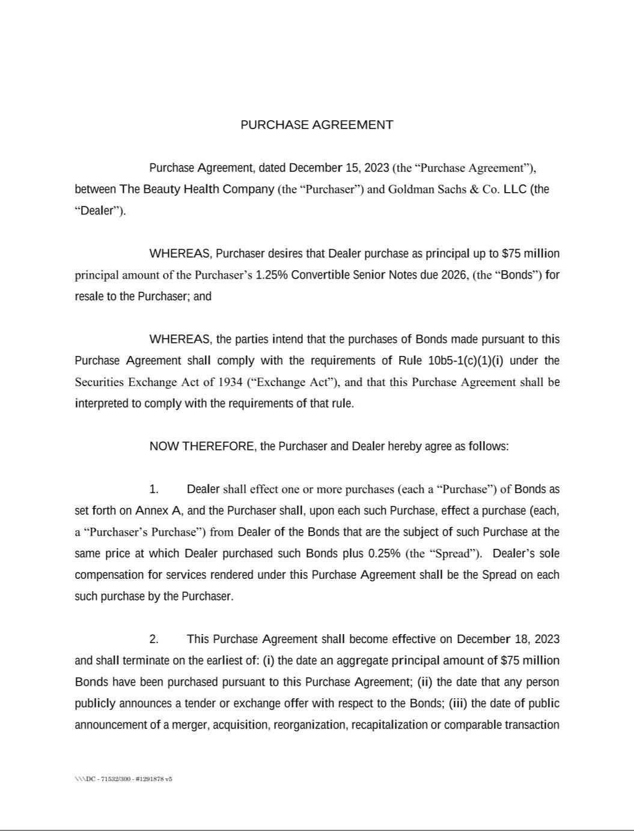

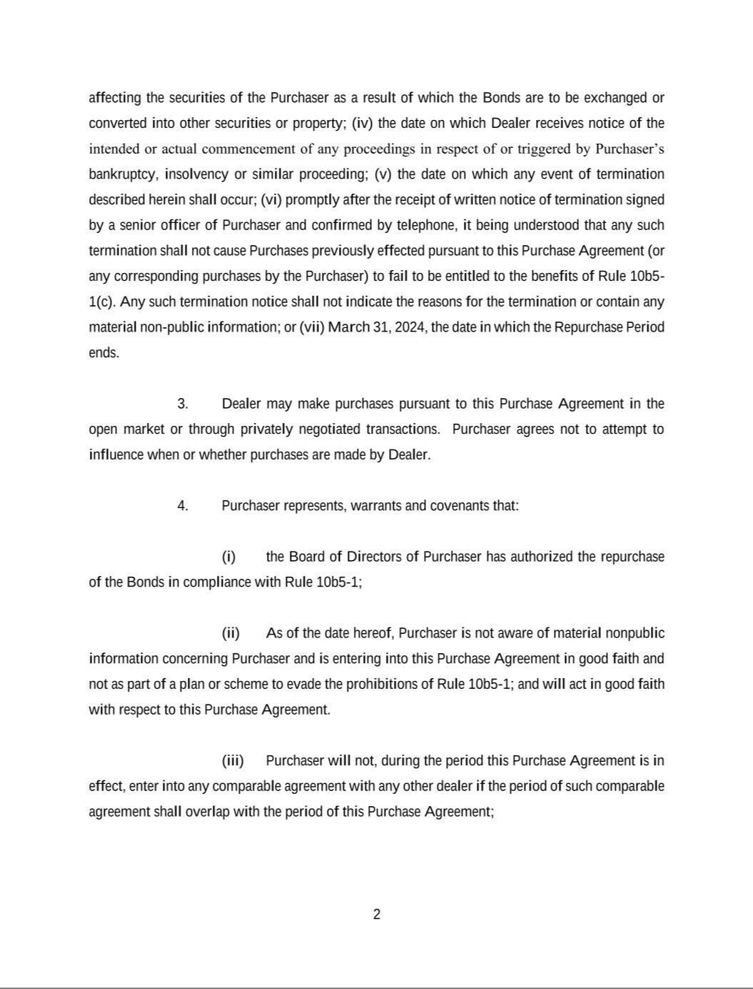

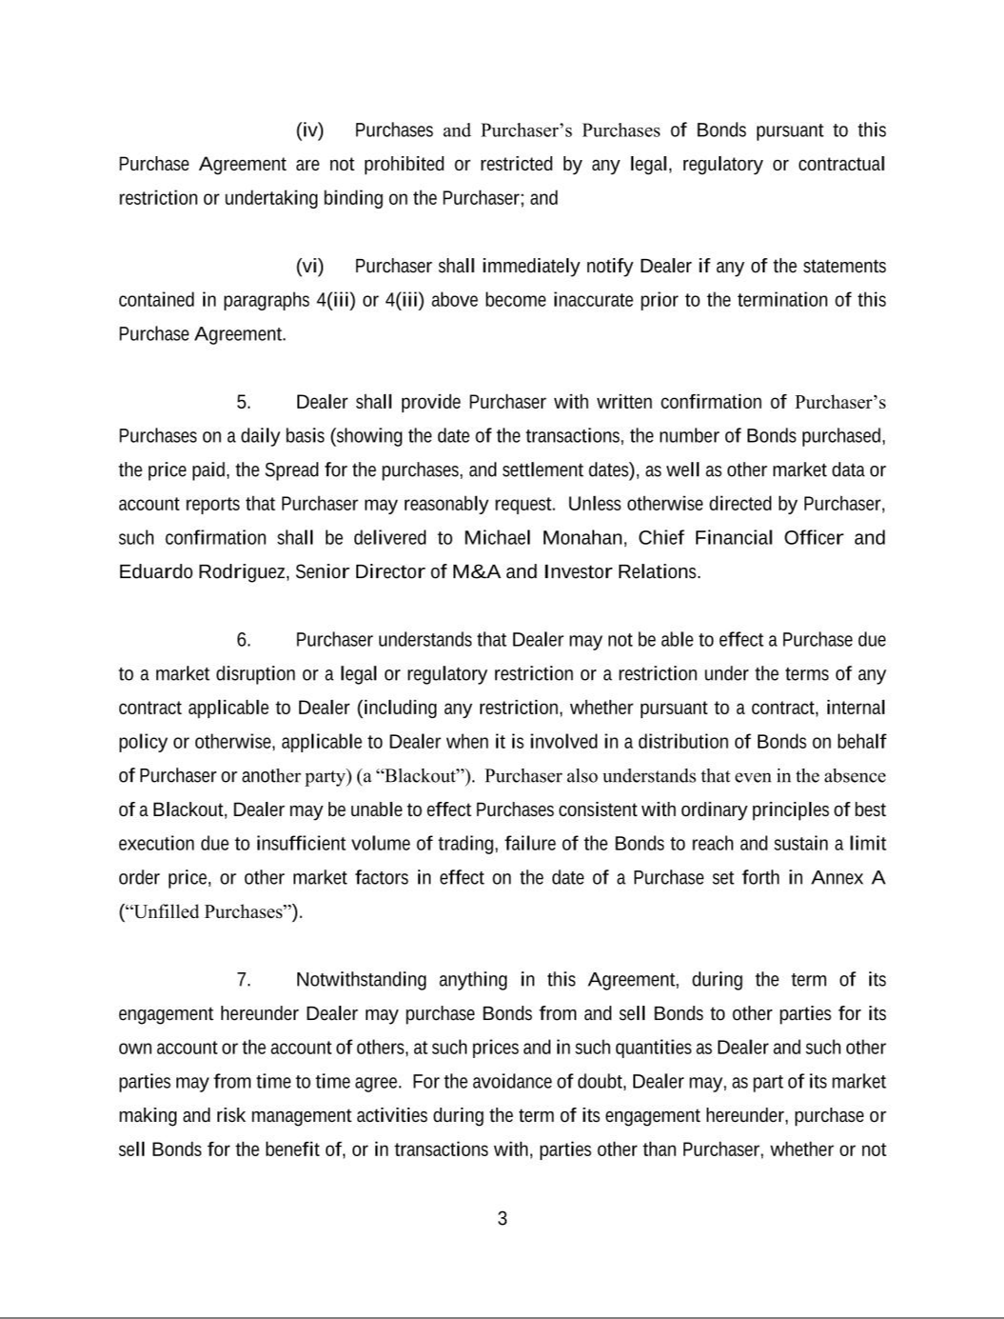

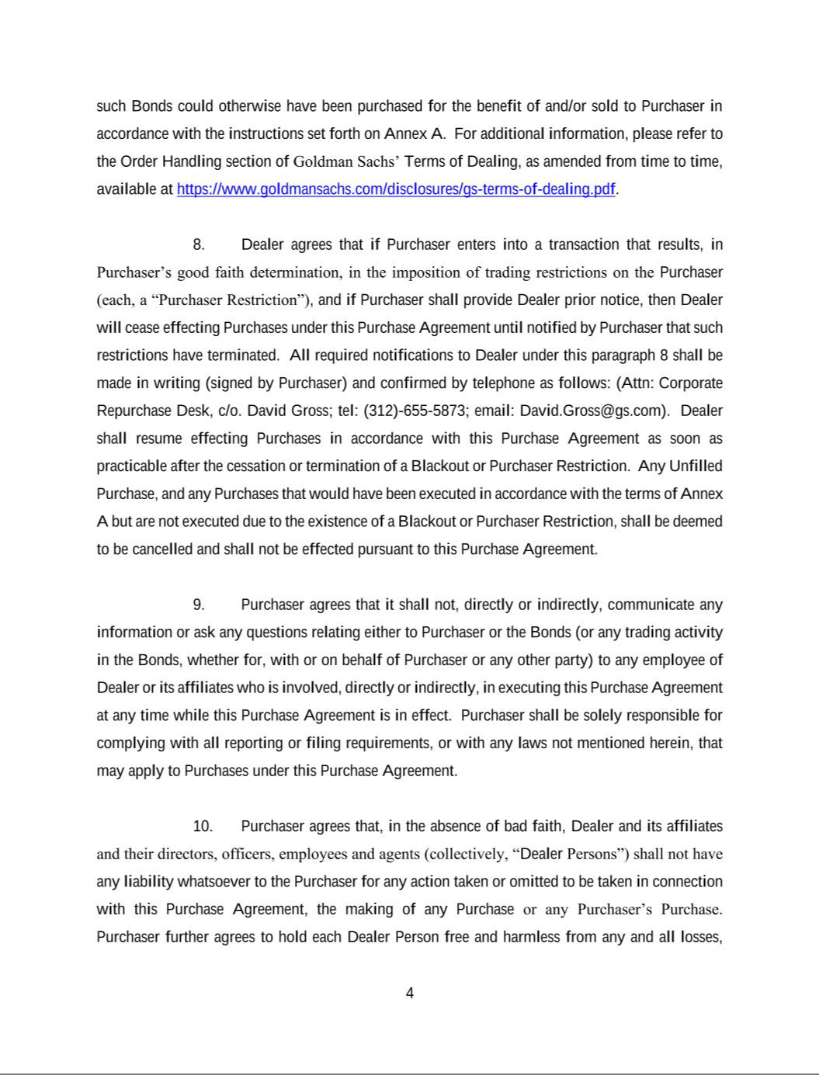

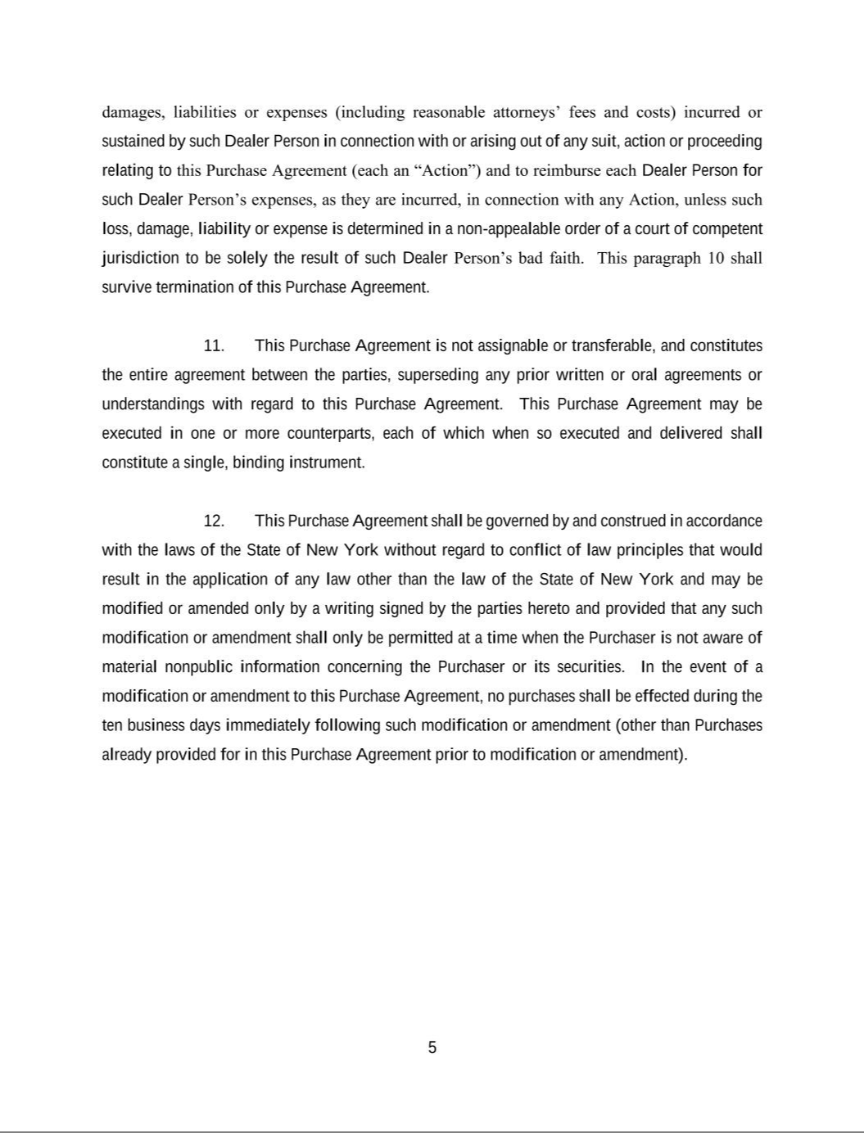

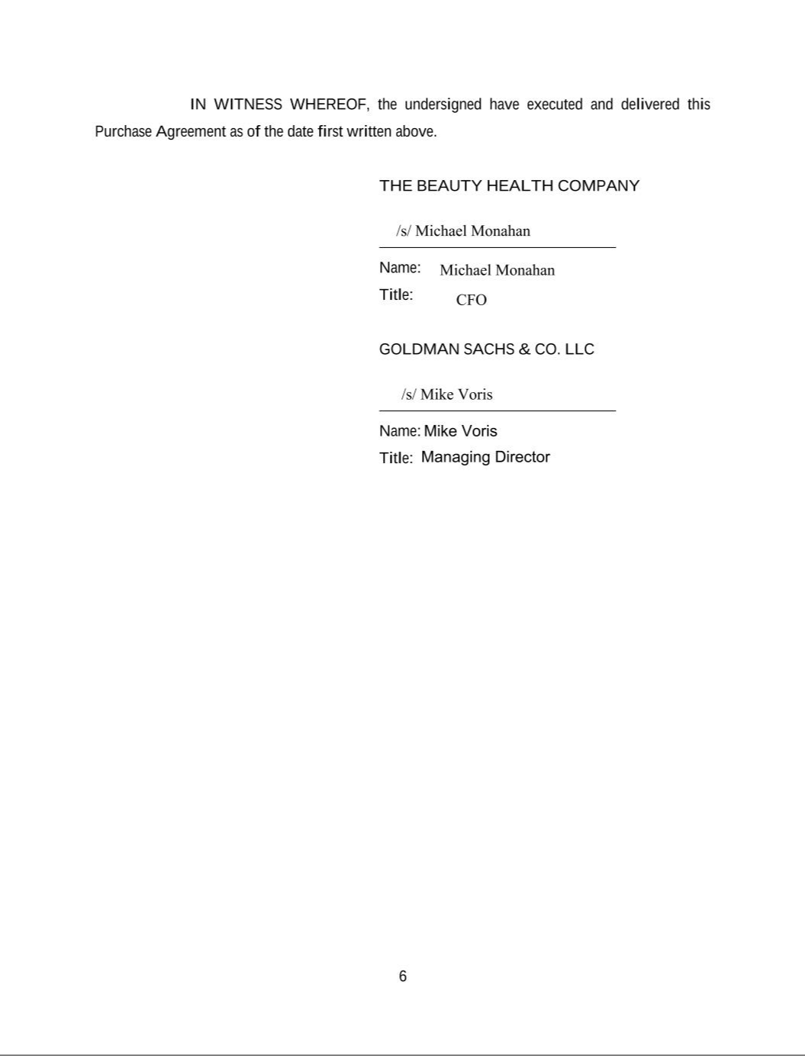

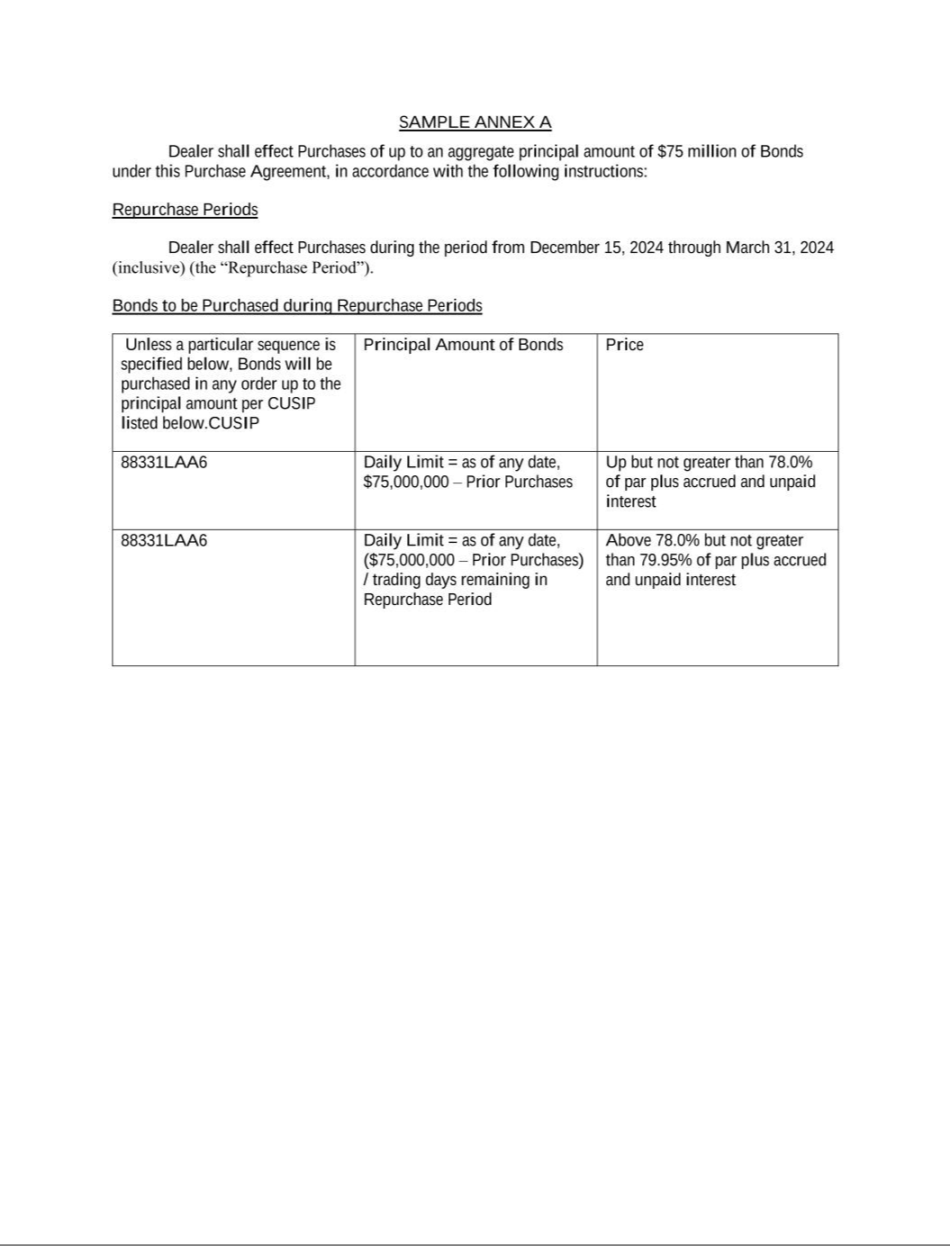

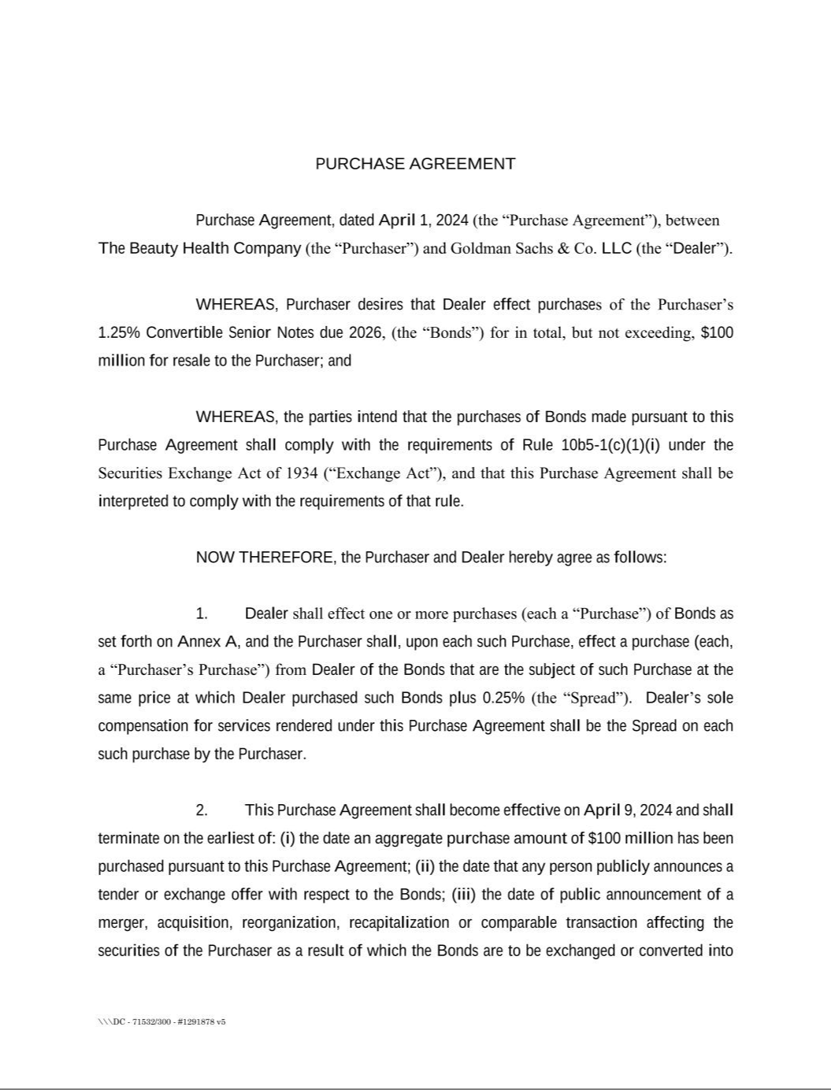

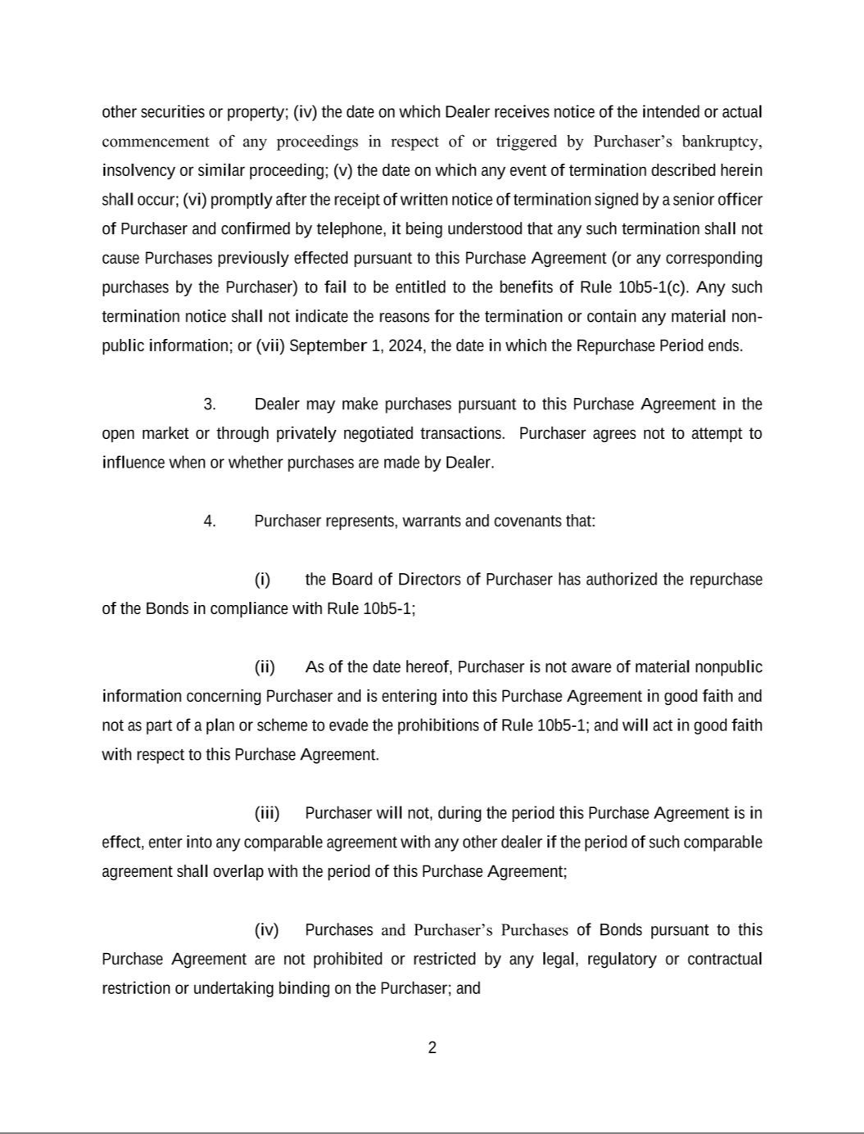

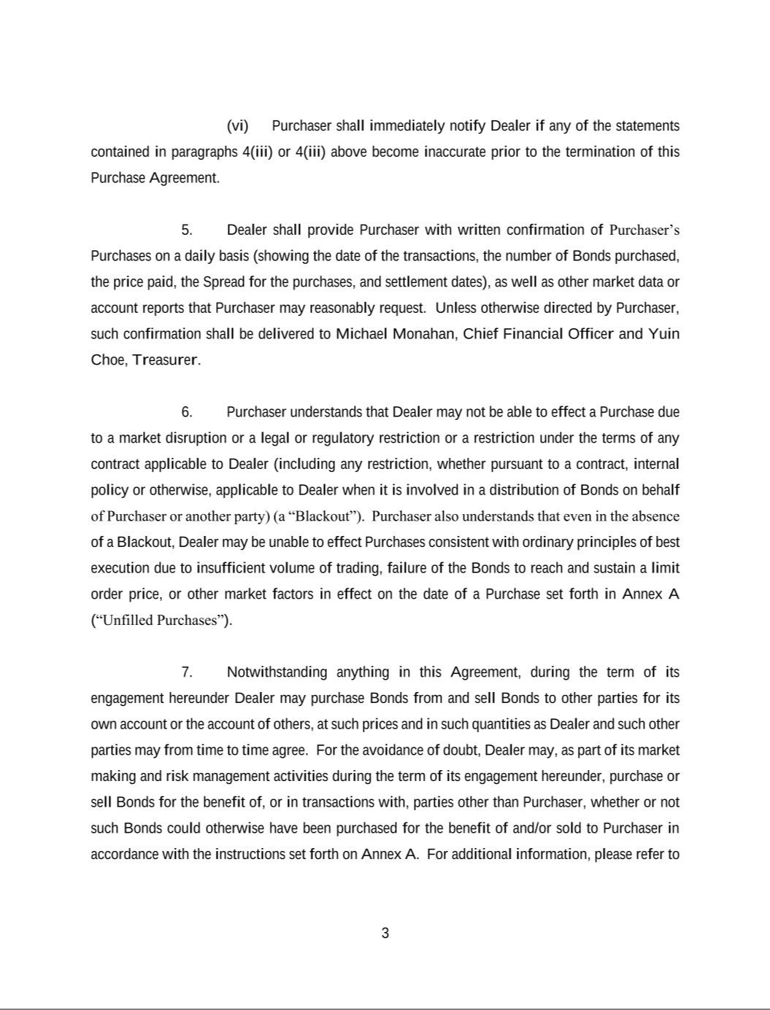

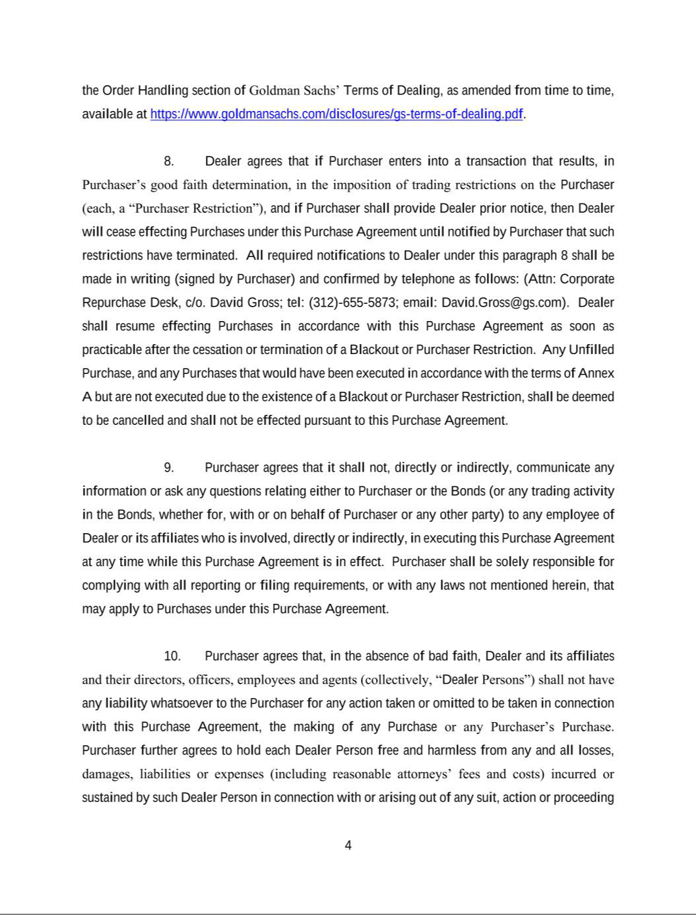

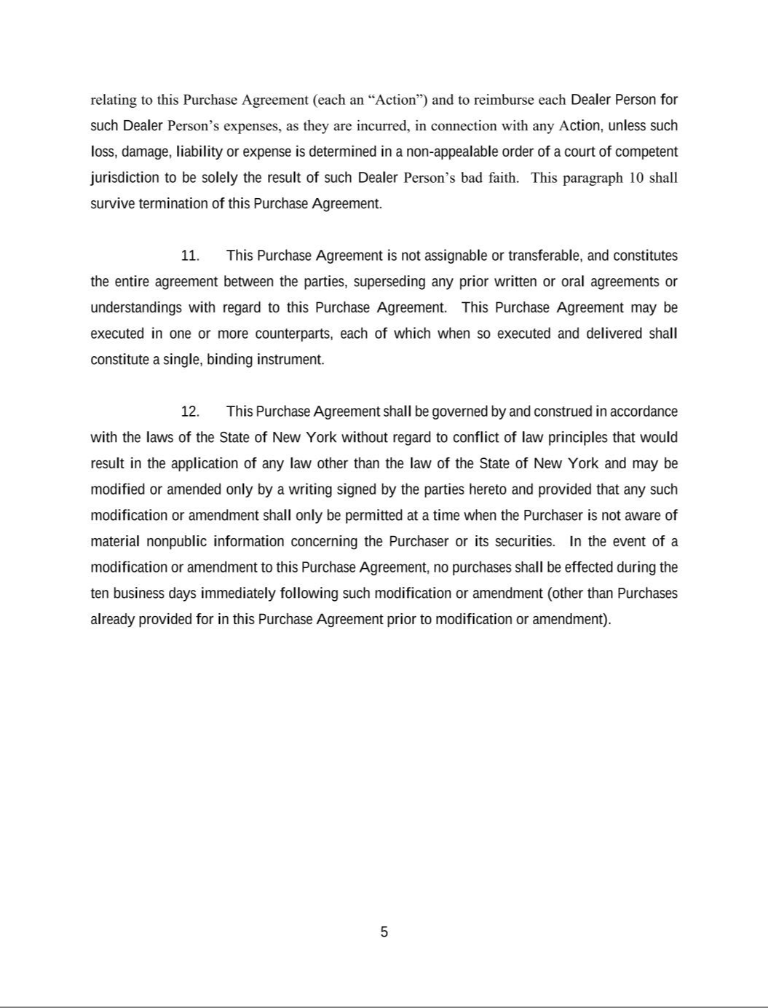

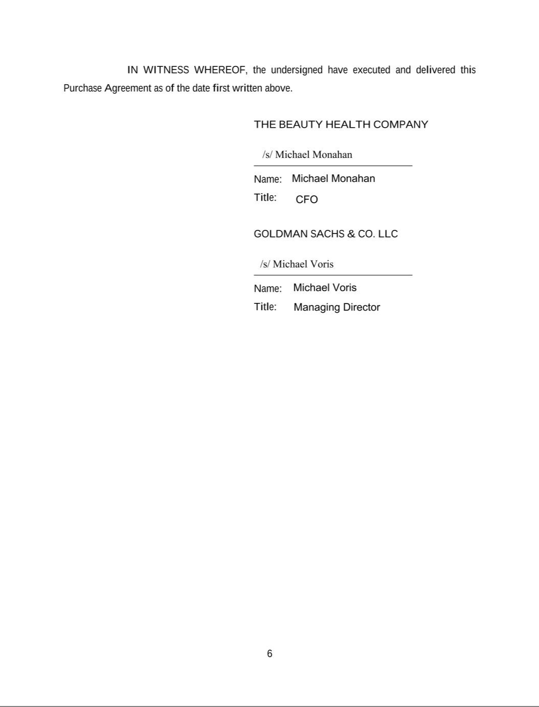

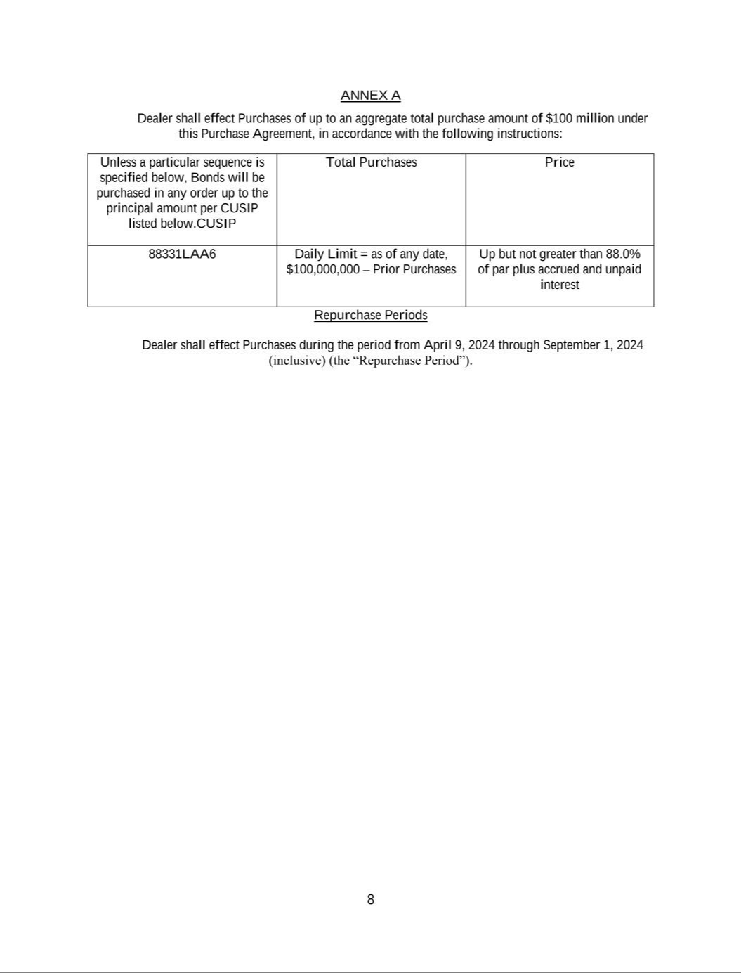

EXHIBIT 31.1

CERTIFICATION OF CHIEF EXECUTIVE OFFICER PURSUANT TO RULE 13A-14(A) UNDER THE SECURITIES EXCHANGE ACT OF 1934, AS ADOPTED PURSUANT TO SECTION 302 OF THE SARBANES-OXLEY ACT OF 2002

I, Marla Beck, certify that:

- I have reviewed this quarterly report on Form 10-Q of The Beauty Health Company;

- Based on my knowledge, this report does not contain any untrue statement of a material fact or omit to state a material fact necessary to make the statements made, in light of the circumstances under which such statements were made, not misleading with respect to the period covered by this report;

- Based on my knowledge, the financial statements, and other financial information included in this report, fairly present in all material respects the financial condition, results of operations and cash flows of the registrant as of, and for, the periods presented in this report;

- The registrant’s other certifying officer and I are responsible for establishing and maintaining disclosure controls and procedures (as defined in Exchange Act Rules 13a-15(e) and 15d-15(e)) and internal control over financial reporting (as defined in Exchange Act Rules 13a-15(f) and 15d-15(f)) for the registrant and have:

  - Designed such disclosure controls and procedures, or caused such disclosure controls and procedures to be designed under our supervision, to ensure that material information relating to the registrant, including its consolidated subsidiaries, is made known to us by others within those entities, particularly during the period in which this report is being prepared;

  - Designed such internal control over financial reporting, or caused such internal control over financial reporting to be designed under our supervision, to provide reasonable assurance regarding the reliability of financial reporting and the preparation of financial statements for external purposes in accordance with generally accepted accounting principles;

  - Evaluated the effectiveness of the registrant’s disclosure controls and procedures and presented in this report our conclusions about the effectiveness of the disclosure controls and procedures, as of the end of the period covered by this report based on such evaluation; and

  - Disclosed in this report any change in the registrant’s internal control over financial reporting that occurred during the registrant’s most recent fiscal quarter (the registrant’s fourth fiscal quarter in the case of an annual report) that has materially affected, or is reasonably likely to materially affect, the registrant’s internal control over financial reporting.

- The registrant’s other certifying officer and I have disclosed, based on our most recent evaluation of internal control over financial reporting, to the registrant’s auditors and the audit committee of the registrant’s board of directors (or persons performing the equivalent functions):

  - All significant deficiencies and material weaknesses in the design or operation of internal control over financial reporting which are reasonably likely to adversely affect the registrant’s ability to record, process, summarize and report financial information; and

  - Any fraud, whether or not material, that involves management or other employees who have a significant role in the registrant’s internal control over financial reporting.

Date: | May 9, 2024
/s/ Marla Beck

Marla Beck

Chief Executive Officer

(Principal Executive Officer)

EXHIBIT 31.2

CERTIFICATION OF CHIEF FINANCIAL OFFICER PURSUANT TO RULE 13A-14(A) UNDER THE SECURITIES EXCHANGE ACT OF 1934, AS ADOPTED PURSUANT TO SECTION 302 OF THE SARBANES-OXLEY ACT OF 2002

I, Michael Monahan, certify that:

- I have reviewed this quarterly report on Form 10-Q of The Beauty Health Company;

- Based on my knowledge, this report does not contain any untrue statement of a material fact or omit to state a material fact necessary to make the statements made, in light of the circumstances under which such statements were made, not misleading with respect to the period covered by this report;

- Based on my knowledge, the financial statements, and other financial information included in this report, fairly present in all material respects the financial condition, results of operations and cash flows of the registrant as of, and for, the periods presented in this report;

- The registrant’s other certifying officer and I are responsible for establishing and maintaining disclosure controls and procedures (as defined in Exchange Act Rules 13a-15(e) and 15d-15(e)) and internal control over financial reporting (as defined in Exchange Act Rules 13a-15(f) and 15d-15(f)) for the registrant and have:

  - Designed such disclosure controls and procedures, or caused such disclosure controls and procedures to be designed under our supervision, to ensure that material information relating to the registrant, including its consolidated subsidiaries, is made known to us by others within those entities, particularly during the period in which this report is being prepared;

  - Designed such internal control over financial reporting, or caused such internal control over financial reporting to be designed under our supervision, to provide reasonable assurance regarding the reliability of financial reporting and the preparation of financial statements for external purposes in accordance with generally accepted accounting principles;

  - Evaluated the effectiveness of the registrant’s disclosure controls and procedures and presented in this report our conclusions about the effectiveness of the disclosure controls and procedures, as of the end of the period covered by this report based on such evaluation; and

  - Disclosed in this report any change in the registrant’s internal control over financial reporting that occurred during the registrant’s most recent fiscal quarter (the registrant’s fourth fiscal quarter in the case of an annual report) that has materially affected, or is reasonably likely to materially affect, the registrant’s internal control over financial reporting.

- The registrant’s other certifying officer and I have disclosed, based on our most recent evaluation of internal control over financial reporting, to the registrant’s auditors and the audit committee of the registrant’s board of directors (or persons performing the equivalent functions):

  - All significant deficiencies and material weaknesses in the design or operation of internal control over financial reporting which are reasonably likely to adversely affect the registrant’s ability to record, process, summarize and report financial information; and

  - Any fraud, whether or not material, that involves management or other employees who have a significant role in the registrant’s internal control over financial reporting.

Date: | May 9, 2024

Michael Monahan

Chief Financial Officer

(Principal Accounting and Financial Officer)

EXHIBIT 32.1

CERTIFICATION PURSUANT TO SECTION 18 U.S.C. SECTION 1350 AS ADOPTED PURSUANT TO SECTION 906 OF THE SARBANES-OXLEY ACT OF 2002

In connection with the Quarterly Report of The Beauty Health Company (the “Company”) on Form 10-Q for the quarterly period ended March 31, 2024, as filed with the Securities and Exchange Commission (the “Report”), I, Marla Beck, Chief Executive Officer of the Company, certify, pursuant to 18 U.S.C. §1350, as added by §906 of the Sarbanes-Oxley Act of 2002, that, to my knowledge:

- The Report fully complies with the requirements of Section 13(a) or 15(d) of the Securities Exchange Act of 1934; and

- The information contained in the Report fairly presents, in all material respects, the financial condition and results of operations of the Company.

Date: | May 9, 2024
/s/ Marla Beck

Marla Beck

Chief Executive Officer

(Principal Executive Officer)

EXHIBIT 32.2

CERTIFICATION PURSUANT TO SECTION 18 U.S.C. SECTION 1350 AS ADOPTED PURSUANT TO SECTION 906 OF THE SARBANES-OXLEY ACT OF 2002

In connection with the Quarterly Report of The Beauty Health Company (the “Company”) on Form 10-Q for the quarterly period ended March 31, 2024, as filed with the Securities and Exchange Commission (the “Report”), I, Michael Monahan, Chief Financial Officer of the Company, certify, pursuant to 18 U.S.C. §1350, as added by §906 of the Sarbanes-Oxley Act of 2002, that, to my knowledge:

- The Report fully complies with the requirements of Section 13(a) or 15(d) of the Securities Exchange Act of 1934; and

- The information contained in the Report fairly presents, in all material respects, the financial condition and results of operations of the Company.

Date: | May 9, 2024
/s/ Michael Monahan

Michael Monahan

Chief Financial Officer

(Principal Accounting and Financial Officer)

